***JAVA CAT-3***

|  |
| --- |
| ***NAME: S.A. HARI PRASAD***  ***ROLLNO: 1831016***  ***DEPARTMENT: COMPUTING***  ***(SOFTWARE SYSTEMS)***  ***YEAR: II YEAR*** |
| ***PROJECT TITLE: FABRIC STOCK MAINTENANCE AND ACCOUNTING PROFIT*** |

**PROJECT AIM:**

To maintain the Fabric and Customer details in Stock which are available and to preform various operations in it. To provide profit accounting to the computed Bills and provide various reports regarding profit analysis.

**PROJECT DESCRIPTION:**

* The fabric stock maintenance aims to store the fabrics details and maintain them. The fabric products will be added, updated and removed from the database at the time of stock storage insert, update and remove. The fabrics can be searched and found whether it is available or not.
* The customer details are stored separately along with their requirements and they are maintained separately. If the product is available the customer makes a purchase but if it is unavailable then when the product once arrives the customer gets notified.
* The bill will be calculated and stored by which the income and expense of the fabric company is separately stored and the company’s profit analysis is maintained and hence it will be useful to find the progress of the company and to increase the customer services.

**GRAPHICAL USER INTERFACE:**

GUI is used in several parts such as the Fabric Stock operations forms, Customer requirement details form and bill storage form with necessary retrieval form. Java Swings and AWT is used for the design of the User Interface.

**DATABASE MANAGEMENT:**

Oracle database is used to store the information in various tables and perform the trigger and view operations to provide the reports

**FUNCTIONALITIES AVAILABLE:**

**Functionalities - Stock Details Maintenance**

* Add fabrics in stock and update fabric details in stock
* Remove fabric details in stock
* Searching availability in a particular fabric with the type and color attributes

**Functionalities - Customer Details Maintenance**

* Add customer details and their requirements
* Reporting when the customer requirement is available and the customer will be displayed with their contact then he can be notified (when the stock table gets added if the customer requirement is matched then the customer is found)
* Search customer details with name and contact to identify their requirements

**Functionalities-Bill Maintenance Module**

* The income and expense bills in the form of sales and purchased bills are stored in the database with bill no and date
* The bills can be searched with bill no by which the details of the bill are displayed.
* Bill is searched with the date and the bill details on that particular day is displayed.

**Functionalities – Profit Accounting Module**

* Profit analysis after each transaction gets calculated and the annual income details are displayed
* The monthly profit details are calculated with the help of views
* To maintain security user enters his registered id and password for acceptance to look crucial information
* The total transactions performed in the menu are triggered and the count of operations are maintained

**USAGE OF DIFFERENT TYPES OF CONTROL:**

**1**) JTextBox:

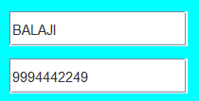

2)JButton:

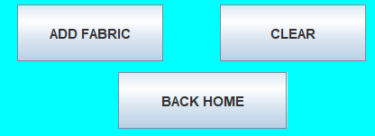

3)JMenuBar, JMenuItem, JMenu:

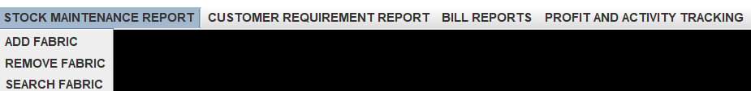

1. JLabel:



1. JComboBox:

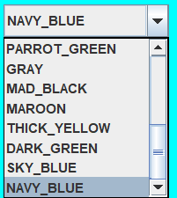

6)JTextArea:

7)JScrollBar:



8)JRadioButton:



9)JPasswordField:



10)JOptionPane:

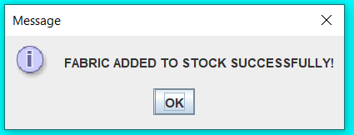

**DATABASE CONNECTIVITY CODE:**

**CONNECTIVITY CODE FOR STOCK MAINTENACE OPERATION MODULE:**

* **Insert Fabric**

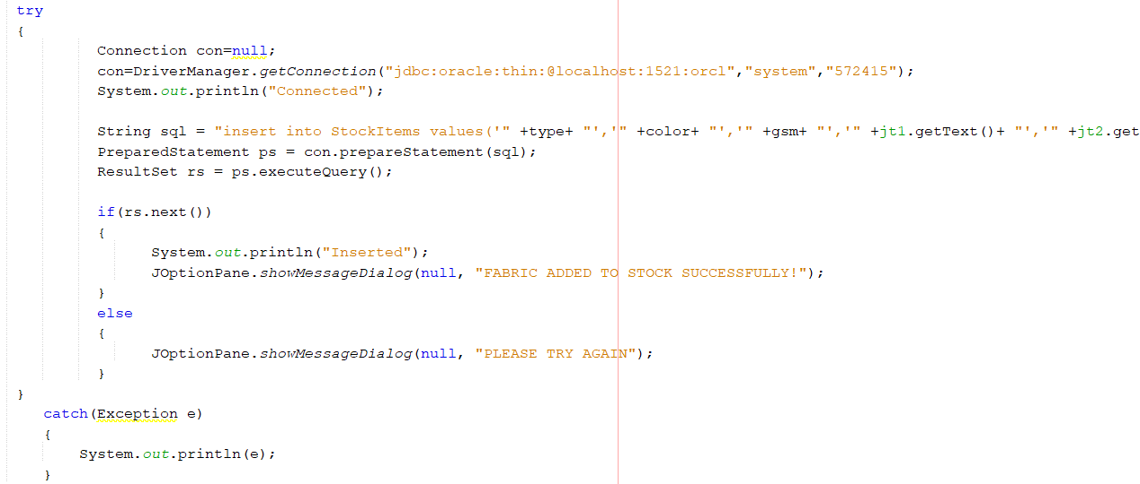

* **Search Fabric**

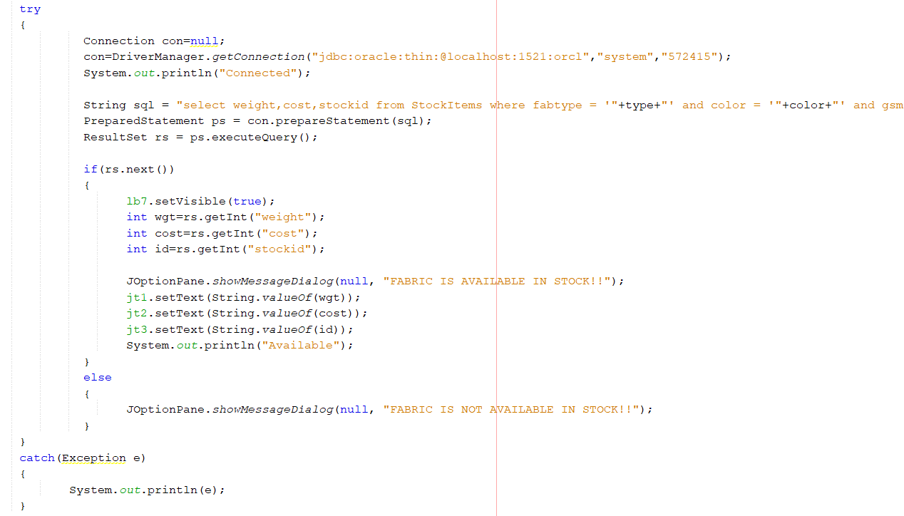

* **Remove Fabric**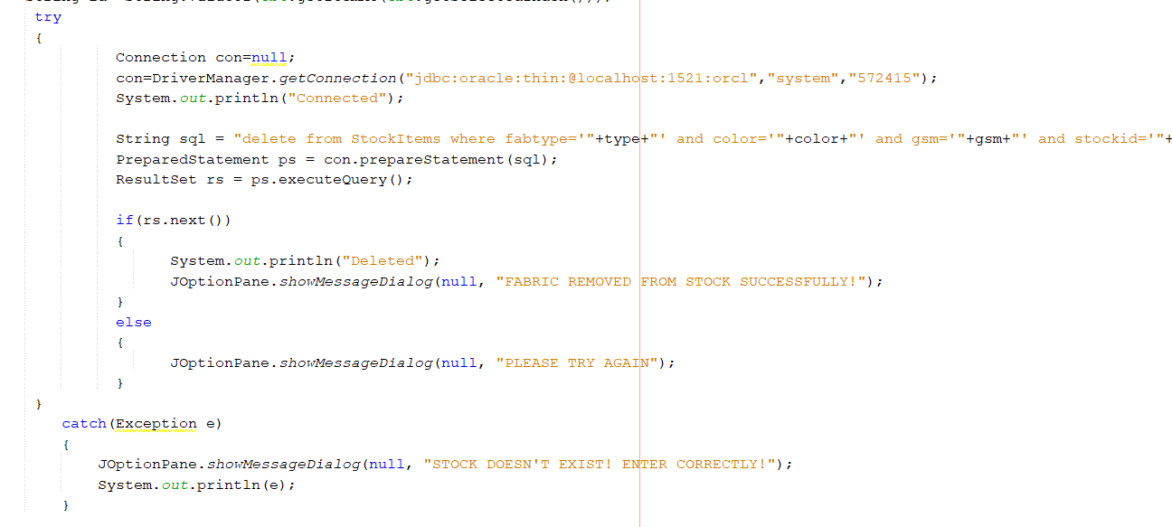

**CONNECTIVITY CODE FOR GETTING CUSTOMER REQUIREMENTS**:

* **INSERTING THE CUSTOMER DETAILS**

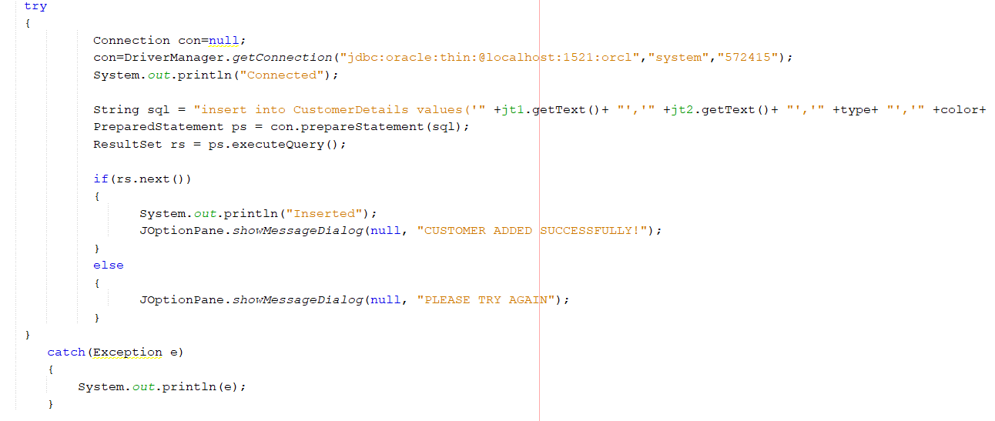

* **SEARCH CUSTOMER WITH REQUIREMENTS:**

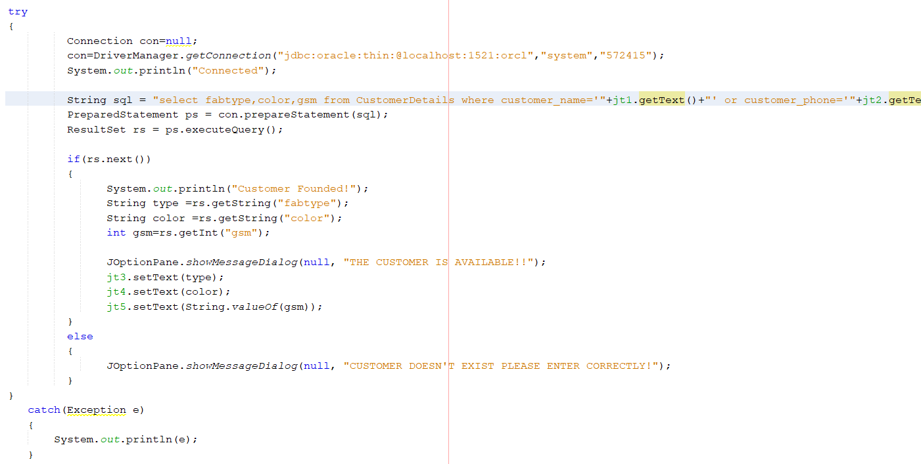

* **READY CUSTOMER REPORT:**

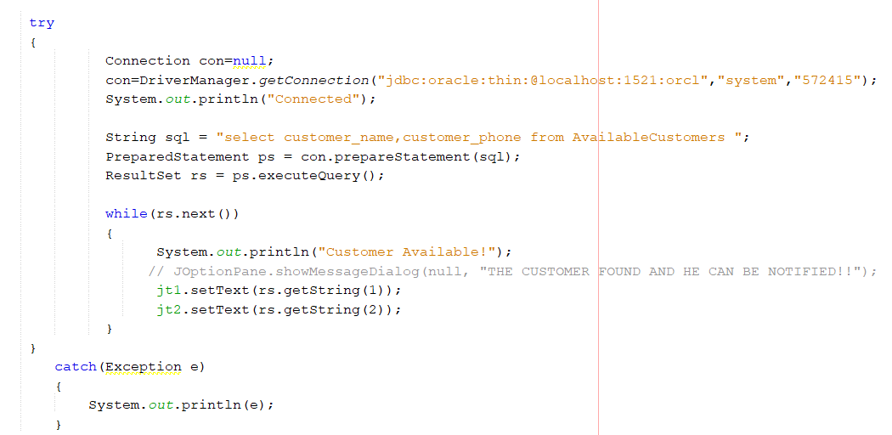

**CONNECTIVITY CODE FOR SALES AND PURCHASE BILL MAINTENANACE:**

* **SALES BILL INSERTION**

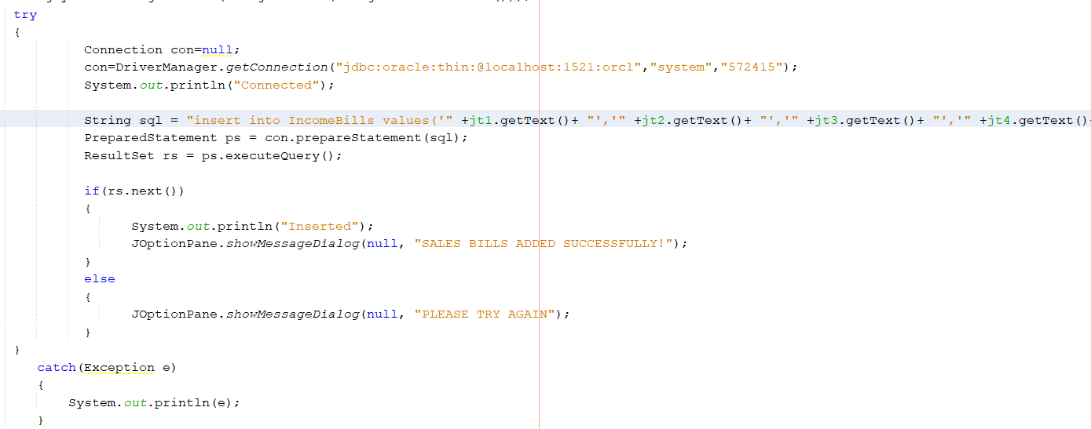

* **PURCHASE BILL INSERTION**

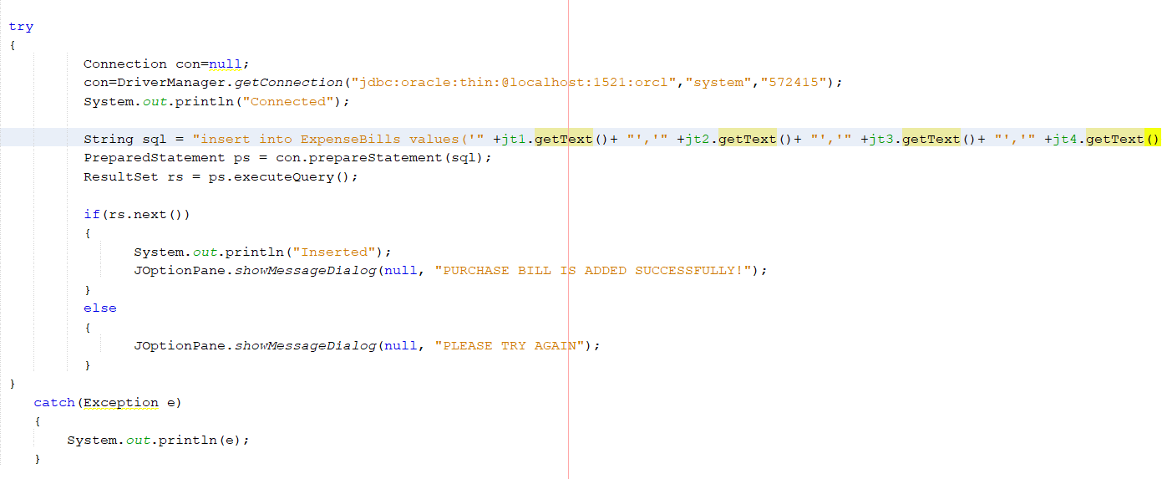

* **SEARCH VIA BILLNO**

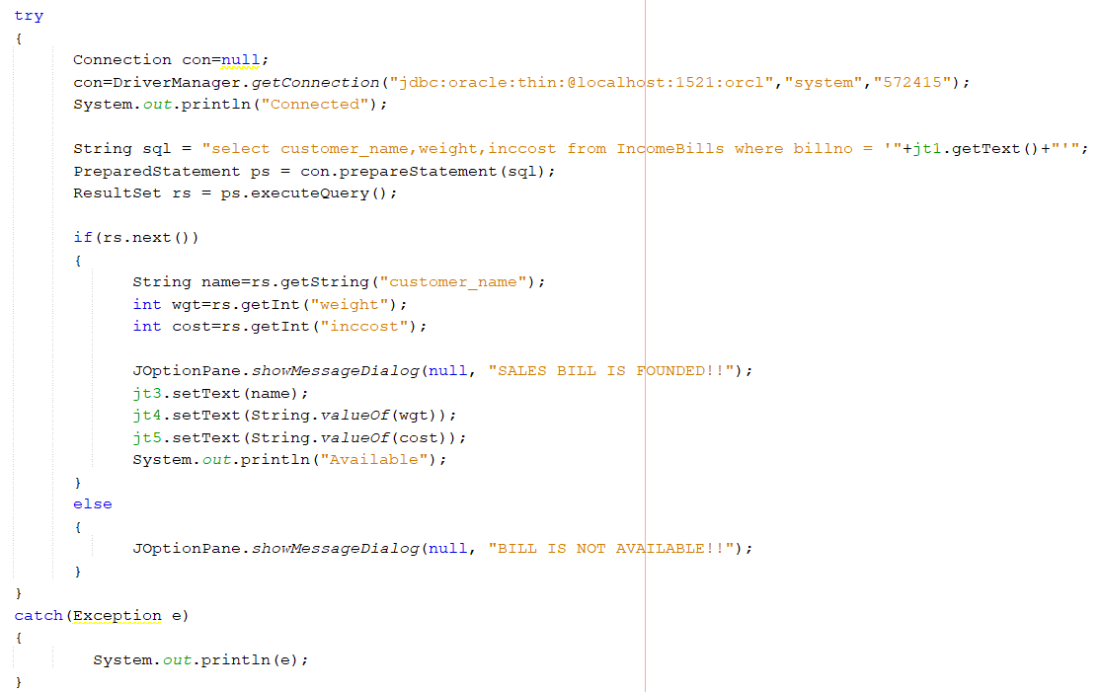

* **SEARCH VIA DATE**

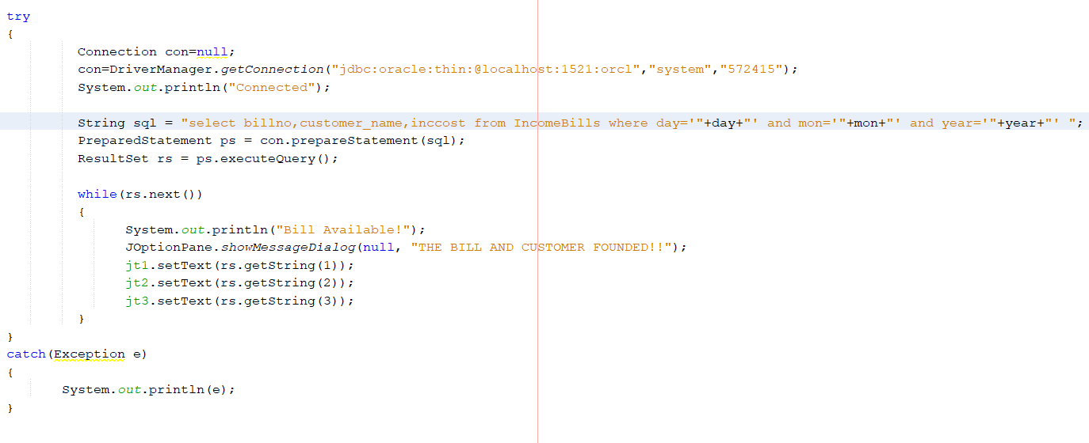

**CONNECTIVITY CODE FOR PROFIT ANALYSIS AND ACTIVITY TRACK:**

* **TRACK ACTIVITIES**

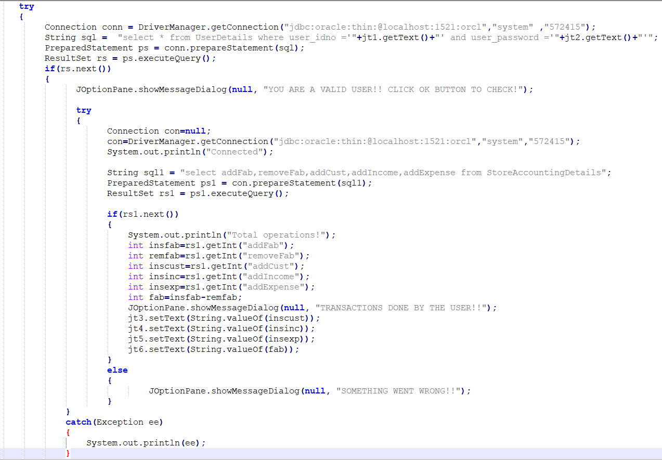

* **ANNUAL PROFIT ANALYSIS**

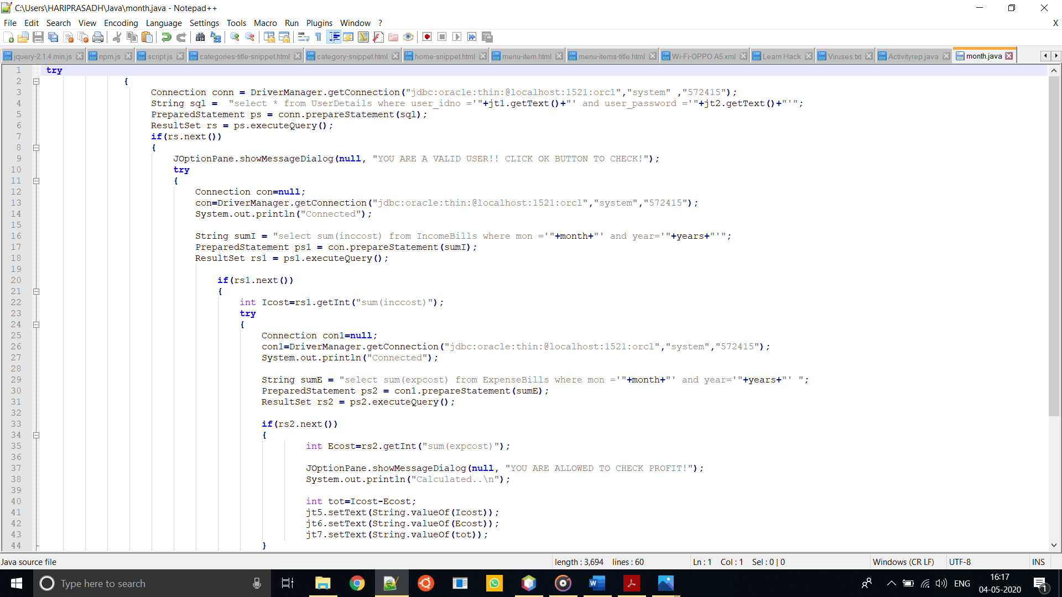

* **MONTHLY PROFIT ANALYSIS**

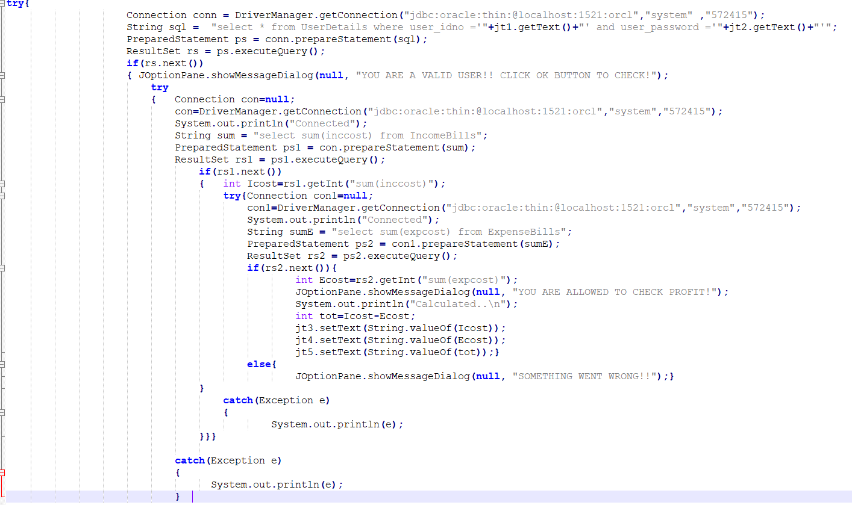

**PROJECT SOURCE CODE:**

* **StockMaintenanceAndAccountingProfit.java**

package stockmaintenanceandaccounting;

import java.awt.*;

import javax.swing.*;

import java.awt.event.*;

public class StockMaintenanceAndAccounting extends Canvas implements ActionListener

{

JFrame f;

JMenuBar mb;

JPanel panel;

JLabel lb1,lb2;

JMenu stock,customer,Billing,Profit;

JMenuItem insertFab,removeFab,searchFab,insertCust,checkStatus,insertIncome,insertExpense,checkProfit,searchBill,searchCust,checkAct,searchBDate,checkMonProfit;

StockMaintenanceAndAccounting()

{

f=new JFrame("STOCK MAINTENANCE AND ACCOUNTING ");

f.getContentPane().setBackground(Color.BLACK);

mb=new JMenuBar();

stock=new JMenu("STOCK MAINTENANCE REPORT");

customer=new JMenu("CUSTOMER REQUIREMENT REPORT");

Billing=new JMenu("BILL REPORTS");

Profit=new JMenu("PROFIT AND ACTIVITY TRACKING");

lb1=new JLabel("UNIQUE FABZ PORTAL");

lb1.setBounds(240,200,400,50);

f.add(lb1);

insertFab=new JMenuItem("ADD FABRIC");

removeFab=new JMenuItem("REMOVE FABRIC");

searchFab=new JMenuItem("SEARCH FABRIC");

insertCust=new JMenuItem("ADD CUSTOMER DETAILS");

checkStatus=new JMenuItem("CHECK READY CUSTOMER");

searchCust=new JMenuItem("SEARCH CUSTOMER");

checkProfit=new JMenuItem("CHECK ANNUAL PROFIT");

insertIncome=new JMenuItem("ADD SALES BILLS");

insertExpense=new JMenuItem("ADD PURCHASED BILLS");

searchBill=new JMenuItem("SEARCH via BILL NO");

checkAct=new JMenuItem("CHECK ACTIVITY");

searchBDate=new JMenuItem("SEARCH via DATE");

checkMonProfit=new JMenuItem("CHECK MONTHLY PROFIT");

stock.add(insertFab);

stock.add(removeFab);

stock.add(searchFab);

customer.add(insertCust);

customer.add(searchCust);

customer.add(checkStatus);

Billing.add(insertIncome);

Billing.add(insertExpense);

Billing.add(searchBill);

Billing.add(searchBDate);

Profit.add(checkAct);

Profit.add(checkProfit);

Profit.add(checkMonProfit);

mb.add(stock);

mb.add(customer);

mb.add(Billing);

mb.add(Profit);

insertFab.addActionListener(this);

removeFab.addActionListener(this);

searchFab.addActionListener(this);

insertCust.addActionListener(this);

insertIncome.addActionListener(this);

insertExpense.addActionListener(this);

checkProfit.addActionListener(this);

checkStatus.addActionListener(this);

searchCust.addActionListener(this);

searchBill.addActionListener(this);

checkAct.addActionListener(this);

searchBDate.addActionListener(this);

checkMonProfit.addActionListener(this);

f.add(mb);

f.setJMenuBar(mb);

panel=new JPanel();

panel.setBounds(100,100,400,400);

panel.setBackground(Color.yellow);

f.add(panel);

f.setLayout(null);

f.setSize(700,700);

f.setVisible(true);

f.setDefaultCloseOperation(f.EXIT_ON_CLOSE);

}

@Override

public void actionPerformed(ActionEvent e)

{

if(e.getSource()==insertFab)

{

f.setVisible(false);

InsertStock addFab= new InsertStock();

f.dispose();

}

if(e.getSource()==removeFab)

{

f.setVisible(false);

RemoveStock remFab= new RemoveStock();

f.dispose();

}

if(e.getSource()==searchFab)

{

f.setVisible(false);

FabricSearch findFab= new FabricSearch();

f.dispose();

}

if(e.getSource()==insertCust)

{

f.setVisible(false);

CustomerDetails addCust=new CustomerDetails();

f.dispose();

}

if(e.getSource()==insertIncome)

{

f.setVisible(false);

IncomeBills insBill= new IncomeBills();

f.dispose();

}

if(e.getSource()==insertExpense)

{

f.setVisible(false);

ExpenseBills expBill= new ExpenseBills();

f.dispose();

}

if(e.getSource()==checkStatus)

{

f.setVisible(false);

StatusCheck findSt= new StatusCheck();

f.dispose();

}

if(e.getSource()==checkAct)

{

f.setVisible(false);

ActivitiyCheck activity= new ActivitiyCheck();

f.dispose();

}

if(e.getSource()==checkProfit)

{

f.setVisible(false);

ProfitCheck findProfit= new ProfitCheck();

f.dispose();

}

if(e.getSource()==searchCust)

{

f.setVisible(false);

CustomerSearch findCust= new CustomerSearch();

f.dispose();

}

if(e.getSource()==searchBill)

{

f.setVisible(false);

BillSearch findBill= new BillSearch();

f.dispose();

}

if(e.getSource()==searchBDate)

{

f.setVisible(false);

BillSearchDate findBillDate= new BillSearchDate();

f.dispose();

}

if(e.getSource()==checkMonProfit)

{

f.setVisible(false);

MonthlyProfit findMonthPro= new MonthlyProfit();

f.dispose();

}

}

public static void main(String[] args)

{

StockMaintenanceAndAccounting s=new StockMaintenanceAndAccounting();

}

}

* **InsertStock.java**

package stockmaintenanceandaccounting;

import java.sql.*;

import java.awt.event.*;

import java.awt.*;

import javax.swing.*;

public class InsertStock implements ActionListener

{

JFrame f;

JTextField jt1,jt2;

JLabel lb1,lb2,lb3,lb4,lb5,lb6;

JButton jb1,jb2,jb3;

JComboBox cb1,cb2,cb3,cb4;

InsertStock()

{

f=new JFrame("ADD FABRICS TO STOCK");

f.getContentPane().setBackground(Color.CYAN);

lb1=new JLabel("ENTER FABRIC TYPE:");

lb1.setBounds(100,50,150,30);

f.add(lb1);

String type[]={"AIRTEX","LYCRA","DURBY","JERSEY"};

cb1=new JComboBox(type);

cb1.setBounds(250,50,150,30);

f.add(cb1);

lb2=new JLabel("ENTER FABRIC COLOR:");

lb2.setBounds(100,90,150,30);

f.add(lb2);

String color[]={"TURKOISE_BLUE","LEMON_YELLOW","VIOLET","BROWN","DARK_RED","WHITE","HALF_WHITE","LIGHT_RED","BABY_PINK","DARK_PINK","PARROT_GREEN","GRAY","MAD_BLACK","MAROON","THICK_YELLOW","DARK_GREEN","SKY_BLUE","NAVY_BLUE"};

cb2=new JComboBox(color);

cb2.setBounds(250,90,150,30);

f.add(cb2);

lb3=new JLabel("ENTER FABRIC GSM:");

lb3.setBounds(100,130,150,30);

f.add(lb3);

String gsm[]={"200","210","220","230","240","250","260","270","280","290","300"};

cb3=new JComboBox(gsm);

cb3.setBounds(250, 130,150,30);

f.add(cb3);

lb4=new JLabel("ENTER TOTAL WEIGHT:");

lb4.setBounds(100,170,150,30);

f.add(lb4);

jt1=new JTextField();

jt1.setBounds(250,170,150,30);

f.add(jt1);

lb5=new JLabel("ENTER COST PER KG:");

lb5.setBounds(100,210,150,30);

f.add(lb5);

jt2=new JTextField();

jt2.setBounds(250,210,150,30);

f.add(jt2);

lb6=new JLabel("ENTER STOCK ID:");

lb6.setBounds(100,250,150,30);

f.add(lb6);

String id[]={"1","2","3"};

cb4=new JComboBox(id);

cb4.setBounds(250, 250,50,20);

f.add(cb4);

jb1=new JButton("ADD FABRIC");

jb1.setBounds(100,340,130,50);

f.add(jb1);

jb2=new JButton("CLEAR");

jb2.setBounds(280,340,130,50);

f.add(jb2);

jb3=new JButton("BACK HOME");

jb3.setBounds(190,400,150,50);

f.add(jb3);

jb1.addActionListener(this);

jb2.addActionListener(this);

jb3.addActionListener(this);

f.setLayout(null);

f.setSize(600,600);

f.setVisible(true);

f.setDefaultCloseOperation(f.EXIT_ON_CLOSE);

}

@Override

public void actionPerformed(ActionEvent ae)

{

if(ae.getSource()==jb1)

{

String type =String.valueOf(cb1.getItemAt(cb1.getSelectedIndex()));

String color =String.valueOf(cb2.getItemAt(cb2.getSelectedIndex()));

String gsm =String.valueOf(cb3.getItemAt(cb3.getSelectedIndex()));

String id =String.valueOf(cb4.getItemAt(cb4.getSelectedIndex()));

try

{

Connection con=null;

con=DriverManager.getConnection("jdbc:oracle:thin:@localhost:1521:orcl","system","572415");

System.out.println("Connected");

String sql = "insert into StockItems values('" +type+ "','" +color+ "','" +gsm+ "','" +jt1.getText()+ "','" +jt2.getText()+ "','" +id+ "')";

PreparedStatement ps = con.prepareStatement(sql); ResultSet rs = ps.executeQuery();

if(rs.next()) {

System.out.println("Inserted");

JOptionPane.showMessageDialog(null, "FABRIC ADDED TO STOCK SUCCESSFULLY!");

}

Else

{

JOptionPane.showMessageDialog(null, "PLEASE TRY AGAIN");

}

}

catch(Exception e)

{

System.out.println(e);

}

}

if(ae.getSource()==jb2)

{

jt1.setText(String.valueOf(""));

jt2.setText(String.valueOf(""));

}

if(ae.getSource()==jb3)

{

StockMaintenanceAndAccounting a=new StockMaintenanceAndAccounting();

f.setVisible(false);

f.dispose();

a.setVisible(true);

}

}

public static void main(String[] args)

{

InsertStock a=new InsertStock();

}

}

* **RemoveStock.java**

package stockmaintenanceandaccounting;

import java.awt.event.*;

import java.awt.*;

import javax.swing.*;

import java.sql.*;

public class RemoveStock implements ActionListener

{

JFrame f;

JLabel lb1,lb2,lb3,lb4,lb5;

JButton jb1,jb2,jb3;

JComboBox cb1,cb2,cb3,cb4;

RemoveStock()

{

f=new JFrame("REMOVE FABRIC FROM STOCK");

f.getContentPane().setBackground(Color.CYAN);

lb1=new JLabel("ENTER FABRIC TYPE:");

lb1.setBounds(100,50,150,30);

f.add(lb1);

String type[]={"AIRTEX","LYCRA","DURBY","JERSEY"};

cb1=new JComboBox(type);

cb1.setBounds(250,50,150,30);

f.add(cb1);

lb2=new JLabel("ENTER FABRIC COLOR:");

lb2.setBounds(100,90,150,30);

f.add(lb2);

String color[]={"TURKOISE_BLUE","LEMON_YELLOW","VIOLET","BROWN","DARK_RED","WHITE","HALF_WHITE","LIGHT_RED","BABY_PINK","DARK_PINK","PARROT_GREEN","GRAY","MAD_BLACK","MAROON","THICK_YELLOW","DARK_GREEN","SKY_BLUE","NAVY_BLUE"};

cb2=new JComboBox(color);

cb2.setBounds(250,90,150,30);

f.add(cb2);

lb3=new JLabel("ENTER FABRIC GSM:");

lb3.setBounds(100,130,150,30);

f.add(lb3);

String gsm[]={"200","210","220","230","240","250","260","270","280","290","300"};

cb3=new JComboBox(gsm);

cb3.setBounds(250, 130,150,30);

f.add(cb3);

lb4=new JLabel("ENTER STOCK ID:");

lb4.setBounds(100,170,150,30);

f.add(lb4);

String id[]={"1","2","3"};

cb4=new JComboBox(id);

cb4.setBounds(250, 170,50,20);

f.add(cb4);

jb1=new JButton("REMOVE FABRIC");

jb1.setBounds(100,280,170,50);

f.add(jb1);

jb2=new JButton("CLEAR");

jb2.setBounds(300,280,170,50);

f.add(jb2);

jb3=new JButton("BACK HOME");

jb3.setBounds(190,400,150,50);

f.add(jb3);

jb1.addActionListener(this);

jb2.addActionListener(this);

jb3.addActionListener(this);

f.setLayout(null);

f.setSize(600,600);

f.setVisible(true);

f.setDefaultCloseOperation(f.EXIT_ON_CLOSE);

}

@Override

public void actionPerformed(ActionEvent ae)

{

if(ae.getSource()==jb1)

{

String type =String.valueOf(cb1.getItemAt(cb1.getSelectedIndex()));

String color =String.valueOf(cb2.getItemAt(cb2.getSelectedIndex()));

String gsm =String.valueOf(cb3.getItemAt(cb3.getSelectedIndex()));

String id =String.valueOf(cb4.getItemAt(cb4.getSelectedIndex()));

try

{

Connection con=null;

con=DriverManager.getConnection("jdbc:oracle:thin:@localhost:1521:orcl","system","572415");

System.out.println("Connected");

String sql = "delete from StockItems where fabtype='"+type+"' and color='"+color+"' and gsm='"+gsm+"' and stockid='"+id+"'";

PreparedStatement ps = con.prepareStatement(sql);

ResultSet rs = ps.executeQuery();

if(rs.next())

{

System.out.println("Deleted");

JOptionPane.showMessageDialog(null, "FABRIC REMOVED FROM STOCK SUCCESSFULLY!");

}

else

{

JOptionPane.showMessageDialog(null, "PLEASE TRY AGAIN");

}

}

catch(Exception e)

{

JOptionPane.showMessageDialog(null, "STOCK DOESN'T EXIST! ENTER CORRECTLY!");

System.out.println(e);

}

}

if(ae.getSource()==jb2)

{ }

if(ae.getSource()==jb3)

{

StockMaintenanceAndAccounting a=new StockMaintenanceAndAccounting();

f.setVisible(false);

f.dispose();

a.setVisible(true);

}

}

public static void main(String[] args)

{

RemoveStock a=new RemoveStock();

}

}

* **FabricSearch.java**

package stockmaintenanceandaccounting;

import java.sql.*;

import java.awt.event.*;

import java.awt.*;

import javax.swing.*;

public class FabricSearch implements ActionListener

{

JFrame f;

JTextField jt1,jt2,jt3;

JLabel lb1,lb2,lb3,lb4,lb5,lb6,lb7;

JButton jb1,jb2,jb3;

JComboBox cb1,cb2,cb3;

FabricSearch()

{

f=new JFrame("SEARCH FABRIC AVAILABILITY");

f.getContentPane().setBackground(Color.CYAN);

lb1=new JLabel("ENTER FABRIC TYPE:");

lb1.setBounds(100,50,150,30);

f.add(lb1);

String type[]={"AIRTEX","LYCRA","DURBY","JERSEY"};

cb1=new JComboBox(type);

cb1.setBounds(250,50,150,30);

f.add(cb1);

lb2=new JLabel("ENTER FABRIC COLOR:");

lb2.setBounds(100,90,150,30);

f.add(lb2);

String color[]={"TURKOISE-BLUE","LEMON_YELLOW","VIOLET","BROWN","DARK_RED","WHITE","HALF_WHITE","LIGHT_RED","BABY_PINK","DARK_PINK","PARROT_GREEN","GRAY","MAD_BLACK","MAROON","THICK_YELLOW","DARK_GREEN","SKY_BLUE","NAVY_BLUE"};

cb2=new JComboBox(color);

cb2.setBounds(250,90,150,30);

f.add(cb2);

lb3=new JLabel("ENTER FABRIC GSM:");

lb3.setBounds(100,130,150,30);

f.add(lb3);

String gsm[]={"200","210","220","230","240","250","260","270","280","290","300"};

cb3=new JComboBox(gsm);

cb3.setBounds(250, 130,150,30);

f.add(cb3);

jb1=new JButton("SEARCH FABRIC");

jb1.setBounds(90,200,140,50);

f.add(jb1);

jb2=new JButton("CLEAR");

jb2.setBounds(300,200,140,50);

f.add(jb2);

lb7=new JLabel("THE EXISTING FABRIC DETAILS ARE DISPLAYED !!");

lb7.setBounds(100,260,380,30);

f.add(lb7);

lb7.setVisible(false);

lb4=new JLabel("AVAILABLE WEIGHT:");

lb4.setBounds(100,300,150,30);

f.add(lb4);

jt1=new JTextField();

jt1.setBounds(250,300,150,30);

f.add(jt1);

lb5=new JLabel("COST PER KG:");

lb5.setBounds(100,340,150,30);

f.add(lb5);

jt2=new JTextField();

jt2.setBounds(250,340,150,30);

f.add(jt2);

lb6=new JLabel("STOCK ROOM ID:");

lb6.setBounds(100,380,150,30);

f.add(lb6);

jt3=new JTextField();

jt3.setBounds(250,380,150,30);

f.add(jt3);

jb3=new JButton("BACK HOME");

jb3.setBounds(190,450,150,50);

f.add(jb3);

jb1.addActionListener(this);

jb2.addActionListener(this);

jb3.addActionListener(this);

f.setLayout(null);

f.setSize(600,600);

f.setVisible(true);

f.setDefaultCloseOperation(f.EXIT_ON_CLOSE);

}

@Override

public void actionPerformed(ActionEvent ae)

{

if(ae.getSource()==jb1)

{

String type =String.valueOf(cb1.getItemAt(cb1.getSelectedIndex()));

String color =String.valueOf(cb2.getItemAt(cb2.getSelectedIndex()));

String gsm =String.valueOf(cb3.getItemAt(cb3.getSelectedIndex()));

try

{

Connection con=null;

con=DriverManager.getConnection("jdbc:oracle:thin:@localhost:1521:orcl","system","572415");

System.out.println("Connected");

String sql = "select weight,cost,stockid from StockItems where fabtype = '"+type+"' and color = '"+color+"' and gsm = '"+gsm+"'";

PreparedStatement ps = con.prepareStatement(sql);

ResultSet rs = ps.executeQuery();

if(rs.next())

{

lb7.setVisible(true);

int wgt=rs.getInt("weight");

int cost=rs.getInt("cost");

int id=rs.getInt("stockid");

JOptionPane.showMessageDialog(null, "FABRIC IS AVAILABLE IN STOCK!!"); jt1.setText(String.valueOf(wgt));

jt2.setText(String.valueOf(cost));

jt3.setText(String.valueOf(id));

System.out.println("Available");

}

else

{

JOptionPane.showMessageDialog(null, "FABRIC IS NOT AVAILABLE IN STOCK!!");

}

}

catch(Exception e)

{

System.out.println(e);

}

}

if(ae.getSource()==jb2)

{

jt1.setText(String.valueOf(""));

jt2.setText(String.valueOf(""));

jt3.setText(String.valueOf(""));

}

if(ae.getSource()==jb3)

{

StockMaintenanceAndAccounting a=new StockMaintenanceAndAccounting();

f.setVisible(false);

f.dispose();

a.setVisible(true);

}

}

public static void main(String[] args)

{

FabricSearch s = new FabricSearch();

}

}

* **CustomerDetails.java**

package stockmaintenanceandaccounting;

import java.sql.*;

import java.awt.event.*;

import java.awt.*;

import javax.swing.*;

public class CustomerDetails implements ActionListener

{

JFrame f;

JTextField jt1,jt2;

JLabel lb1,lb2,lb3,lb4,lb5;

JButton jb1,jb2,jb3;

JComboBox cb1,cb2,cb3;

CustomerDetails()

{

f=new JFrame("CUSTOMER DETAILS WITH REQUIREMENTS");

f.getContentPane().setBackground(Color.CYAN);

lb1=new JLabel("ENTER CUSTOMER NAME:");

lb1.setBounds(100,50,200,30);

f.add(lb1);

jt1=new JTextField();

jt1.setBounds(330,50,150,30);

f.add(jt1);

lb2=new JLabel("ENTER CUSTOMER CONTACT:");

lb2.setBounds(100,90,200,30);

f.add(lb2);

jt2=new JTextField();

jt2.setBounds(330,90,150,30);

f.add(jt2);

lb3=new JLabel("ENTER FABRIC TYPE:");

lb3.setBounds(100,130,150,30);

f.add(lb3);

String type[]={"AIRTEX","LYCRA","DURBY","JERSEY"};

cb1=new JComboBox(type);

cb1.setBounds(250,130,150,30);

f.add(cb1);

lb4=new JLabel("ENTER FABRIC COLOR:");

lb4.setBounds(100,170,150,30);

f.add(lb4);

String color[]={"TURKOISE_BLUE","LEMON_YELLOW","VIOLET","BROWN","DARK_RED","WHITE","HALF_WHITE","LIGHT_RED","BABY_PINK","DARK_PINK","PARROT_GREEN","GRAY","MAD_BLACK","MAROON","THICK_YELLOW","DARK_GREEN","SKY_BLUE","NAVY_BLUE"};

cb2=new JComboBox(color);

cb2.setBounds(250,170,150,30);

f.add(cb2);

lb5=new JLabel("ENTER FABRIC GSM:");

lb5.setBounds(100,210,150,30);

f.add(lb5);

String gsm[]={"200","210","220","230","240","250","260","270","280","290","300"};

cb3=new JComboBox(gsm);

cb3.setBounds(250, 210,150,30);

f.add(cb3);

jb1=new JButton("ADD CUSTOMER");

jb1.setBounds(100,300,170,50);

f.add(jb1);

jb2=new JButton("CLEAR");

jb2.setBounds(300,300,130,50);

f.add(jb2);

jb3=new JButton("BACK HOME");

jb3.setBounds(190,400,150,50);

f.add(jb3);

jb1.addActionListener(this);

jb2.addActionListener(this);

jb3.addActionListener(this);

f.setLayout(null);

f.setSize(600,600);

f.setVisible(true);

f.setDefaultCloseOperation(f.EXIT_ON_CLOSE);

}

@Override

public void actionPerformed(ActionEvent ae)

{

if(ae.getSource()==jb1)

{

String type =String.valueOf(cb1.getItemAt(cb1.getSelectedIndex()));

String color =String.valueOf(cb2.getItemAt(cb2.getSelectedIndex()));

String gsm =String.valueOf(cb3.getItemAt(cb3.getSelectedIndex()));

try

{

Connection con=null; con=DriverManager.getConnection("jdbc:oracle:thin:@localhost:1521:orcl","system","572415");

System.out.println("Connected");

String sql = "insert into CustomerDetails values('" +jt1.getText()+ "','" +jt2.getText()+ "','" +type+ "','" +color+ "','" +gsm+ "')";

PreparedStatement ps = con.prepareStatement(sql);

ResultSet rs = ps.executeQuery();

if(rs.next())

{

System.out.println("Inserted");

JOptionPane.showMessageDialog(null, "CUSTOMER ADDED SUCCESSFULLY!");

}

else

{

JOptionPane.showMessageDialog(null, "PLEASE TRY AGAIN");

}

}

catch(Exception e)

{

System.out.println(e);

}

}

if(ae.getSource()==jb2)

{

jt1.setText(String.valueOf(""));

jt2.setText(String.valueOf(""));

}

if(ae.getSource()==jb3)

{

StockMaintenanceAndAccounting a=new StockMaintenanceAndAccounting();

f.setVisible(false);

f.dispose();

a.setVisible(true);

}

}

public static void main(String[] args)

{

CustomerDetails a=new CustomerDetails();

}

}

* **CustomerSearch.java**

package stockmaintenanceandaccounting;

import java.sql.*;

import java.awt.event.*;

import java.awt.*;

import javax.swing.*;

public class CustomerDetails implements ActionListener

{

JFrame f;

JTextField jt1,jt2;

JLabel lb1,lb2,lb3,lb4,lb5;

JButton jb1,jb2,jb3;

JComboBox cb1,cb2,cb3;

CustomerDetails()

{

f=new JFrame("CUSTOMER DETAILS WITH REQUIREMENTS");

f.getContentPane().setBackground(Color.CYAN);

lb1=new JLabel("ENTER CUSTOMER NAME:");

lb1.setBounds(100,50,200,30);

f.add(lb1);

jt1=new JTextField();

jt1.setBounds(330,50,150,30);

f.add(jt1);

lb2=new JLabel("ENTER CUSTOMER CONTACT:");

lb2.setBounds(100,90,200,30);

f.add(lb2);

jt2=new JTextField();

jt2.setBounds(330,90,150,30);

f.add(jt2);

lb3=new JLabel("ENTER FABRIC TYPE:");

lb3.setBounds(100,130,150,30);

f.add(lb3);

String type[]={"AIRTEX","LYCRA","DURBY","JERSEY"};

cb1=new JComboBox(type);

cb1.setBounds(250,130,150,30);

f.add(cb1);

lb4=new JLabel("ENTER FABRIC COLOR:");

lb4.setBounds(100,170,150,30);

f.add(lb4);

String color[]={"TURKOISE_BLUE","LEMON_YELLOW","VIOLET","BROWN","DARK_RED","WHITE","HALF_WHITE","LIGHT_RED","BABY_PINK","DARK_PINK","PARROT_GREEN","GRAY","MAD_BLACK","MAROON","THICK_YELLOW","DARK_GREEN","SKY_BLUE","NAVY_BLUE"};

cb2=new JComboBox(color);

cb2.setBounds(250,170,150,30);

f.add(cb2);

lb5=new JLabel("ENTER FABRIC GSM:");

lb5.setBounds(100,210,150,30);

f.add(lb5);

String gsm[]={"200","210","220","230","240","250","260","270","280","290","300"};

cb3=new JComboBox(gsm);

cb3.setBounds(250, 210,150,30);

f.add(cb3);

jb1=new JButton("ADD CUSTOMER");

jb1.setBounds(100,300,170,50);

f.add(jb1);

jb2=new JButton("CLEAR");

jb2.setBounds(300,300,130,50);

f.add(jb2);

jb3=new JButton("BACK HOME");

jb3.setBounds(190,400,150,50);

f.add(jb3);

jb1.addActionListener(this);

jb2.addActionListener(this);

jb3.addActionListener(this);

f.setLayout(null);

f.setSize(600,600);

f.setVisible(true);

f.setDefaultCloseOperation(f.EXIT_ON_CLOSE);

}

@Override

public void actionPerformed(ActionEvent ae)

{

if(ae.getSource()==jb1)

{

String type =String.valueOf(cb1.getItemAt(cb1.getSelectedIndex()));

String color =String.valueOf(cb2.getItemAt(cb2.getSelectedIndex()));

String gsm =String.valueOf(cb3.getItemAt(cb3.getSelectedIndex()));

try

{

Connection con=null;

con=DriverManager.getConnection("jdbc:oracle:thin:@localhost:1521:orcl","system","572415");

System.out.println("Connected");

String sql = "insert into CustomerDetails values('" +jt1.getText()+ "','" +jt2.getText()+ "','" +type+ "','" +color+ "','" +gsm+ "')";

PreparedStatement ps = con.prepareStatement(sql);

ResultSet rs = ps.executeQuery();

if(rs.next())

{

System.out.println("Inserted");

JOptionPane.showMessageDialog(null, "CUSTOMER ADDED SUCCESSFULLY!");

}

else

{

JOptionPane.showMessageDialog(null, "PLEASE TRY AGAIN");

}

}

catch(Exception e)

{

System.out.println(e);

}

}

if(ae.getSource()==jb2)

{

jt1.setText(String.valueOf(""));

jt2.setText(String.valueOf(""));

}

if(ae.getSource()==jb3)

{

StockMaintenanceAndAccounting a=new StockMaintenanceAndAccounting();

f.setVisible(false);

f.dispose();

a.setVisible(true);

}

}

public static void main(String[] args)

{

CustomerDetails a=new CustomerDetails();

}

}

* **StatusCheck.java**

package stockmaintenanceandaccounting;

import java.awt.*;

import java.awt.event.*;

import java.sql.*;

import javax.swing.*;

public class StatusCheck implements ActionListener

{

JFrame f;

JTextArea jt1,jt2;

JLabel lb1;

JButton jb1,jb2;

StatusCheck()

{

f=new JFrame("READY CUSTOMER DETAILS");

f.getContentPane().setBackground(Color.YELLOW);

jb1=new JButton("LIST READY CUSTOMER");

jb1.setBounds(100,50,300,50);

f.add(jb1);

lb1=new JLabel("CUSTOMERS WHOSE STOCK IS AVAILABLE:");

lb1.setBounds(100,150,300,30);

f.add(lb1);

jt1=new JTextArea();

jt1.setBounds(150,200,150,50);

f.add(jt1);

jt2=new JTextArea();

jt2.setBounds(150,260,150,50);

f.add(jt2);

jb2=new JButton("BACK HOME");

jb2.setBounds(150,330,150,50);

f.add(jb2);

jb1.addActionListener(this);

jb2.addActionListener(this);

f.setLayout(null);

f.setSize(500,500);

f.setVisible(true);

f.setDefaultCloseOperation(f.EXIT_ON_CLOSE);

}

@Override

public void actionPerformed(ActionEvent ae)

{

if(ae.getSource()==jb1)

{

try

{

Connection con=null; con=DriverManager.getConnection("jdbc:oracle:thin:@localhost:1521:orcl","system","572415");

System.out.println("Connected");

String sql = "select customer_name,customer_phone from AvailableCustomers ";

PreparedStatement ps = con.prepareStatement(sql);

ResultSet rs = ps.executeQuery();

while(rs.next())

{

System.out.println("Customer Available!");

JOptionPane.showMessageDialog(null, "THE CUSTOMER FOUND AND HE CAN BE NOTIFIED!!");

jt1.setText(rs.getString(1));

jt2.setText(rs.getString(2));

}

}

catch(Exception e)

{

System.out.println(e);

}

}

if(ae.getSource()==jb2)

{

StockMaintenanceAndAccounting a=new StockMaintenanceAndAccounting();

f.setVisible(false);

f.dispose();

a.setVisible(true);

}

}

public static void main(String[] args)

{

StatusCheck s =new StatusCheck();

}

}

* **IncomeBills.java**

package stockmaintenanceandaccounting;

import java.awt.event.*;

import java.awt.*;

import java.sql.*;

import javax.swing.*;

public class IncomeBills implements ActionListener

{

JFrame f;

JTextField jt1,jt2,jt3,jt4;

JLabel lb1,lb2,lb3,lb4,lb5;

JButton jb1,jb2,jb3;

JComboBox cb1,cb2,cb3;

IncomeBills()

{

f=new JFrame("ADD INCOME BILLS");

f.getContentPane().setBackground(Color.YELLOW);

lb1=new JLabel("ENTER CUSTOMER NAME:");

lb1.setBounds(100,50,200,30);

f.add(lb1);

jt1=new JTextField();

jt1.setBounds(280,50,150,30);

f.add(jt1);

lb2=new JLabel("ENTER BILL NO:");

lb2.setBounds(100,90,150,30);

f.add(lb2);

jt2=new JTextField();

jt2.setBounds(280,90,150,30);

f.add(jt2);

lb3=new JLabel("ENTER TOTAL WEIGHT:");

lb3.setBounds(100,130,150,30);

f.add(lb3);

jt3=new JTextField();

jt3.setBounds(280,130,150,30);

f.add(jt3);

lb4=new JLabel("AMOUNT RECIEVED:");

lb4.setBounds(100,170,150,30);

f.add(lb4);

jt4=new JTextField();

jt4.setBounds(280,170,150,30);

f.add(jt4);

lb5=new JLabel("DATE:(DAY/MON/YEAR)");

lb5.setBounds(100,220,150,30);

f.add(lb5);

String day[]={"1","2","3","4","5","6","7","8","9","10","11","12","13","14","15","16","17","18","19","20","21","22","23","24","25","26","27","28","29","30","31"};

cb1=new JComboBox(day);

cb1.setBounds(280,220,50,30);

f.add(cb1);

String month[]={"JAN","FEB","MAR","APR","MAY","JUN","JUL","AUG","SEP","OCT","NOV","DEC"};

cb2=new JComboBox(month);

cb2.setBounds(360,220,60,30);

f.add(cb2);

String year[]={"2020","2021"};

cb3=new JComboBox(year);

cb3.setBounds(450,220,80,30);

f.add(cb3);

jb1=new JButton("ADD SALES BILL");

jb1.setBounds(100,300,180,50);

f.add(jb1);

jb2=new JButton("CLEAR");

jb2.setBounds(310,300,130,50);

f.add(jb2);

jb3=new JButton("BACK HOME");

jb3.setBounds(190,400,150,50);

f.add(jb3);

jb1.addActionListener(this);

jb2.addActionListener(this);

jb3.addActionListener(this);

f.setLayout(null);

f.setSize(600,600);

f.setVisible(true);

f.setDefaultCloseOperation(f.EXIT_ON_CLOSE);

}

@Override

public void actionPerformed(ActionEvent ae)

{

if(ae.getSource()==jb1)

{

String day =String.valueOf(cb1.getItemAt(cb1.getSelectedIndex()));

String mon =String.valueOf(cb2.getItemAt(cb2.getSelectedIndex()));

String year =String.valueOf(cb3.getItemAt(cb3.getSelectedIndex()));

try

{

Connection con=null; con=DriverManager.getConnection("jdbc:oracle:thin:@localhost:1521:orcl","system","572415");

System.out.println("Connected");

String sql = "insert into IncomeBills values('" +jt1.getText()+ "','" +jt2.getText()+ "','" +jt3.getText()+ "','" +jt4.getText()+ "','" +day+ "','" +mon+ "','" +year+ "')";

PreparedStatement ps = con.prepareStatement(sql);

ResultSet rs = ps.executeQuery();

if(rs.next())

{

System.out.println("Inserted");

JOptionPane.showMessageDialog(null, "SALES BILLS ADDED SUCCESSFULLY!");

}

else

{

JOptionPane.showMessageDialog(null, "PLEASE TRY AGAIN");

}

}

catch(Exception e)

{

System.out.println(e);

}

}

if(ae.getSource()==jb2)

{

jt1.setText(String.valueOf(""));

jt2.setText(String.valueOf(""));

jt3.setText(String.valueOf(""));

jt4.setText(String.valueOf(""));

}

if(ae.getSource()==jb3)

{

StockMaintenanceAndAccounting a=new StockMaintenanceAndAccounting();

f.setVisible(false);

f.dispose();

a.setVisible(true);

}

}

public static void main(String[] args)

{

IncomeBills a=new IncomeBills();

}

}

* **ExpenseBills.java**

package stockmaintenanceandaccounting;

import java.awt.*;

import java.awt.event.*;

import java.sql.*;

import javax.swing.*;

public class ExpenseBills implements ActionListener

{

JFrame f;

JTextField jt1,jt2,jt3,jt4,jt5,jt6,jt7;

JLabel lb1,lb2,lb3,lb4,lb5;

JButton jb1,jb2,jb3;

JComboBox cb1,cb2,cb3;

ExpenseBills()

{

f=new JFrame("ADD PURCHASED BILLS");

f.getContentPane().setBackground(Color.YELLOW);

lb1=new JLabel("ENTER SUPPLIER NAME:");

lb1.setBounds(100,50,150,30);

f.add(lb1);

jt1=new JTextField();

jt1.setBounds(280,50,150,30);

f.add(jt1);

lb2=new JLabel("ENTER BILL NO:");

lb2.setBounds(100,90,150,30);

f.add(lb2);

jt2=new JTextField();

jt2.setBounds(280,90,150,30);

f.add(jt2);

lb3=new JLabel("ENTER TOTAL WEIGHT:");

lb3.setBounds(100,130,150,30);

f.add(lb3);

jt3=new JTextField();

jt3.setBounds(280,130,150,30);

f.add(jt3);

lb4=new JLabel("AMOUNT PAID:");

lb4.setBounds(100,170,150,30);

f.add(lb4);

jt4=new JTextField();

jt4.setBounds(280,170,150,30);

f.add(jt4);

lb5=new JLabel("DATE:(DAY/MON/YEAR)");

lb5.setBounds(100,220,150,30);

f.add(lb5);

String day[]={"1","2","3","4","5","6","7","8","9","10","11","12","13","14","15","16","17","18","19","20","21","22","23","24","25","26","27","28","29","30","31"};

cb1=new JComboBox(day);

cb1.setBounds(280,220,50,30);

f.add(cb1);

String month[]={"JAN","FEB","MAR","APR","MAY","JUN","JUL","AUG","SEP","OCT","NOV","DEC"};

cb2=new JComboBox(month);

cb2.setBounds(360,220,60,30);

f.add(cb2);

String year[]={"2020","2021"};

cb3=new JComboBox(year);

cb3.setBounds(450,220,80,30);

f.add(cb3);

jb1=new JButton("ADD PURCHASED BILLS");

jb1.setBounds(100,300,200,50);

f.add(jb1);

jb2=new JButton("CLEAR");

jb2.setBounds(320,300,130,50);

f.add(jb2);

jb3=new JButton("BACK HOME");

jb3.setBounds(190,400,150,50);

f.add(jb3);

jb1.addActionListener(this);

jb2.addActionListener(this);

jb3.addActionListener(this);

f.setLayout(null);

f.setSize(600,600);

f.setVisible(true);

f.setDefaultCloseOperation(f.EXIT_ON_CLOSE);

}

@Override

public void actionPerformed(ActionEvent ae)

{

if(ae.getSource()==jb1)

{

String day =String.valueOf(cb1.getItemAt(cb1.getSelectedIndex()));

String mon =String.valueOf(cb2.getItemAt(cb2.getSelectedIndex()));

String year =String.valueOf(cb3.getItemAt(cb3.getSelectedIndex()));

try

{

Connection con=null;

con=DriverManager.getConnection("jdbc:oracle:thin:@localhost:1521:orcl","system","572415");

System.out.println("Connected");

String sql = "insert into ExpenseBills values('" +jt1.getText()+ "','" +jt2.getText()+ "','" +jt3.getText()+ "','" +jt4.getText()+ "','" +day+ "','" +mon+ "','" +year+ "')";

PreparedStatement ps = con.prepareStatement(sql);

ResultSet rs = ps.executeQuery();

if(rs.next())

{

System.out.println("Inserted");

JOptionPane.showMessageDialog(null, "PURCHASE BILL IS ADDED SUCCESSFULLY!");

}

else

{

JOptionPane.showMessageDialog(null, "PLEASE TRY AGAIN");

}

}

catch(Exception e)

{

System.out.println(e);

}

}

if(ae.getSource()==jb2)

{

jt1.setText(String.valueOf(""));

jt2.setText(String.valueOf(""));

jt3.setText(String.valueOf(""));

jt4.setText(String.valueOf(""));

}

if(ae.getSource()==jb3)

{

StockMaintenanceAndAccounting a=new StockMaintenanceAndAccounting();

f.setVisible(false);

f.dispose();

a.setVisible(true);

}

}

public static void main(String[] args)

{

ExpenseBills a=new ExpenseBills();

}

}

* **BillSearch.java**

package stockmaintenanceandaccounting;

import java.sql.*;

import java.awt.event.*;

import java.awt.*;

import javax.swing.*;

public class BillSearch implements ActionListener

{

JFrame f;

JTextField jt1,jt3,jt4,jt5;

JLabel lb1,lb2,lb3,lb4,lb5,lb6;

JButton jb1,jb2,jb3;

JRadioButton r1,r2;

ButtonGroup bg;

BillSearch()

{

f=new JFrame("SEARCH BILL DETAILS");

f.getContentPane().setBackground(Color.YELLOW);

lb1=new JLabel("ENTER BILL NO:");

lb1.setBounds(100,50,150,30);

f.add(lb1);

jt1=new JTextField();

jt1.setBounds(250,50,150,30);

f.add(jt1);

lb2=new JLabel("ENTER BILL TYPE:");

lb2.setBounds(100,90,250,30);

f.add(lb2);

r1=new JRadioButton("Sales");

r2=new JRadioButton("Purchased");

r1.setBounds(250,90,100,30);

r2.setBounds(360,90,100,30);

bg=new ButtonGroup();

bg.add(r1);

bg.add(r2);

f.add(r1);

f.add(r2);

jb1=new JButton("SEARCH BILL DETAILS");

jb1.setBounds(100,140,210,30);

f.add(jb1);

jb2=new JButton("CLEAR");

jb2.setBounds(340,140,150,30);

f.add(jb2);

lb3=new JLabel("BILL DETAILS ARE DISPLAYED BELOW IF EXISTS!!");

lb3.setBounds(100,220,380,30);

f.add(lb3);

lb4=new JLabel("CUSTOMER/SELLER NAME:");

lb4.setBounds(100,260,200,30);

f.add(lb4);

jt3=new JTextField();

jt3.setBounds(300,260,150,30);

f.add(jt3);

lb5=new JLabel("WEIGHT OF FABRIC:");

lb5.setBounds(100,300,200,30);

f.add(lb5);

jt4=new JTextField();

jt4.setBounds(300,300,150,30);

f.add(jt4);

lb6=new JLabel("AMOUNT RECIEVED/PAID:");

lb6.setBounds(100,340,150,30);

f.add(lb6);

jt5=new JTextField();

jt5.setBounds(300,340,200,30);

f.add(jt5);

jb3=new JButton("BACK HOME");

jb3.setBounds(190,400,150,50);

f.add(jb3);

jb1.addActionListener(this);

jb2.addActionListener(this);

jb3.addActionListener(this);

f.setLayout(null);

f.setSize(600,600);

f.setVisible(true);

f.setDefaultCloseOperation(f.EXIT_ON_CLOSE);

}

@Override

public void actionPerformed(ActionEvent ae)

{

if(ae.getSource()==jb1)

{

if(r1.isSelected())

{

lb4.setText("CUSTOMER NAME:");

lb6.setText("AMOUNT RECIEVED:");

try

{

Connection con=null; con=DriverManager.getConnection("jdbc:oracle:thin:@localhost:1521:orcl","system","572415");

System.out.println("Connected");

String sql = "select customer_name,weight,inccost from IncomeBills where billno = '"+jt1.getText()+"'";

PreparedStatement ps = con.prepareStatement(sql);

ResultSet rs = ps.executeQuery();

if(rs.next())

{

String name=rs.getString("customer_name");

int wgt=rs.getInt("weight");

int cost=rs.getInt("inccost");

JOptionPane.showMessageDialog(null, "SALES BILL IS FOUNDED!!");

jt3.setText(name); jt4.setText(String.valueOf(wgt));

jt5.setText(String.valueOf(cost));

System.out.println("Available");

}

else

{

JOptionPane.showMessageDialog(null, "BILL IS NOT AVAILABLE!!");

}

}

catch(Exception e)

{

System.out.println(e);

}

}

if(r2.isSelected())

{

lb4.setText("SUPPLIER NAME:");

lb6.setText("AMOUNT PAID:");

try

{

Connection con=null;

con=DriverManager.getConnection("jdbc:oracle:thin:@localhost:1521:orcl","system","572415");

System.out.println("Connected");

String sql = "select * from ExpenseBills where billno = '"+jt1.getText()+"'";

PreparedStatement ps = con.prepareStatement(sql);

ResultSet rs = ps.executeQuery();

if(rs.next())

{

String name=rs.getString("supplier_name");

int wgt=rs.getInt("weight");

int cost=rs.getInt("expcost");

JOptionPane.showMessageDialog(null, "PURCHASED BILL IS FOUNDED!!");

jt3.setText(String.valueOf(name));

jt4.setText(String.valueOf(wgt));

jt5.setText(String.valueOf(cost));

System.out.println("Available");

}

else

{

JOptionPane.showMessageDialog(null, "BILL IS NOT AVAILABLE!!");

}

}

catch(Exception e)

{

System.out.println(e)

}

}

}

if(ae.getSource()==jb2)

{

jt1.setText(String.valueOf(""));

jt3.setText(String.valueOf(""));

jt4.setText(String.valueOf(""));

jt5.setText(String.valueOf(""));

}

if(ae.getSource()==jb3)

{

StockMaintenanceAndAccounting a=new StockMaintenanceAndAccounting();

f.setVisible(false);

f.dispose();

a.setVisible(true);

}

}

public static void main(String[] args)

{

BillSearch s = new BillSearch();

}

}

* **BillSearchDate.java**

package stockmaintenanceandaccounting;

import java.sql.*;

import java.awt.event.*;

import java.awt.*;

import javax.swing.*;

public class BillSearchDate implements ActionListener

{

JFrame f;

JTextField jt1,jt2,jt3;

JLabel lb1,lb2,lb3,lb4,lb5,lb6;

JButton jb1,jb2,jb3;

JComboBox cb1,cb2,cb3;

BillSearchDate()

{

f=new JFrame("SEARCH DATE TO FIND BILL");

f.getContentPane().setBackground(Color.CYAN);

lb1=new JLabel("ENTER DATE (DD/MMM/YYY):");

lb1.setBounds(100,80,230,30);

f.add(lb1);

String day[]={"1","2","3","4","5","6","7","8","9","10","11","12","13","14","15","16","17","18","19","20","21","22","23","24","25","26","27","28","29","30","31"};

cb1=new JComboBox(day);

cb1.setBounds(300,80,50,30);

f.add(cb1);

String month[]={"JAN","FEB","MAR","APR","MAY","JUN","JUL","AUG","SEP","OCT","NOV","DEC"};

cb2=new JComboBox(month);

cb2.setBounds(370,80,60,30);

f.add(cb2);

String year[]={"2020","2021"};

cb3=new JComboBox(year);

cb3.setBounds(450,80,70,30);

f.add(cb3);

jb1=new JButton("SEARCH BILL DETAILS");

jb1.setBounds(100,140,210,30);

f.add(jb1);

jb2=new JButton("CLEAR");

jb2.setBounds(340,140,150,30);

f.add(jb2);

lb2=new JLabel("BILL DETAILS ARE DISPLAYED BELOW IF EXISTS!!");

lb2.setBounds(100,220,380,30);

f.add(lb2);

lb3=new JLabel("BILL NO:");

lb3.setBounds(100,260,200,30);

f.add(lb3);

jt1=new JTextField();

jt1.setBounds(300,260,150,30);

f.add(jt1);

lb4=new JLabel("CUSTOMER NAME:");

lb4.setBounds(100,300,200,30);

f.add(lb4);

jt2=new JTextField();

jt2.setBounds(300,300,150,30);

f.add(jt2);

lb5=new JLabel("AMOUNT RECIEVED:");

lb5.setBounds(100,340,150,30);

f.add(lb5);

jt3=new JTextField();

jt3.setBounds(300,340,200,30);

f.add(jt3);

jb3=new JButton("BACK HOME");

jb3.setBounds(190,400,150,50);

f.add(jb3);

jb1.addActionListener(this);

jb2.addActionListener(this);

jb3.addActionListener(this);

f.setLayout(null);

f.setSize(600,600);

f.setVisible(true);

f.setDefaultCloseOperation(f.EXIT_ON_CLOSE);

}

@Override

public void actionPerformed(ActionEvent ae)

{

if(ae.getSource()==jb1)

{

String day

=String.valueOf(cb1.getItemAt(cb1.getSelectedIndex()));

String mon =String.valueOf(cb2.getItemAt(cb2.getSelectedIndex()));

String year=String.valueOf(cb3.getItemAt(cb3.getSelectedIndex()));

try

{

Connection con=null; con=DriverManager.getConnection("jdbc:oracle:thin:@localhost:1521:orcl","system","572415");

System.out.println("Connected");

String sql = "select billno,customer_name,inccost from IncomeBills where day='"+day+"' and mon='"+mon+"' and year='"+year+"' ";

PreparedStatement ps = con.prepareStatement(sql);

ResultSet rs = ps.executeQuery();

while(rs.next())

{

System.out.println("Bill Available!");

JOptionPane.showMessageDialog(null, "THE BILL AND CUSTOMER FOUNDED!!");

jt1.setText(rs.getString(1));

jt2.setText(rs.getString(2));

jt3.setText(rs.getString(3));

}

}

catch(Exception e)

{

System.out.println(e);

}

}

if(ae.getSource()==jb2)

{

jt1.setText(String.valueOf(""));

jt2.setText(String.valueOf(""));

jt3.setText(String.valueOf(""));

}

if(ae.getSource()==jb3)

{

StockMaintenanceAndAccounting a=new StockMaintenanceAndAccounting();

f.setVisible(false);

f.dispose();

a.setVisible(true);

}

}

public static void main(String[] args)

{

BillSearchDate s = new BillSearchDate();

}

}

* **ActivityCheck.java**

package stockmaintenanceandaccounting;

import java.sql.*;

import java.awt.event.*;

import java.awt.*;

import javax.swing.*;

public class ActivitiyCheck implements ActionListener

{

JFrame f;

JPasswordField jt2;

JTextField jt1,jt3,jt4,jt5,jt6;

JLabel lb1,lb2,lb3,lb4,lb5,lb6;

JButton jb1,jb2,jb3;

ActivitiyCheck()

{

f=new JFrame("CHECK TRANSACTION DETAILS");

f.getContentPane().setBackground(Color.YELLOW);

lb1=new JLabel("ENTER USERNAME:");

lb1.setBounds(100,40,200,30);

f.add(lb1);

jt1=new JTextField();

jt1.setBounds(300,40,150,30);

f.add(jt1);

lb2=new JLabel("ENTER PASSWORD:");

lb2.setBounds(100,80,200,30);

f.add(lb2);

jt2=new JPasswordField();

jt2.setBounds(300,80,150,30);

f.add(jt2);

jb1=new JButton("CHECK DETAILS");

jb1.setBounds(100,120,140,50);

f.add(jb1);

jb2=new JButton("CLEAR");

jb2.setBounds(300,120,140,50);

f.add(jb2);

lb3=new JLabel("NO.OF ORDERS RECIEVED:");

lb3.setBounds(100,180,200,30);

f.add(lb3);

jt3=new JTextField();

jt3.setBounds(300,180,150,30);

f.add(jt3);

lb4=new JLabel("NO.OF SALES BILLS:");

lb4.setBounds(100,230,150,30);

f.add(lb4);

jt4=new JTextField();

jt4.setBounds(300,230,150,30);

f.add(jt4);

lb5=new JLabel("NO.OF PURCHASE BILLS:");

lb5.setBounds(100,280,200,30);

f.add(lb5);

jt5=new JTextField();

jt5.setBounds(300,280,150,30);

f.add(jt5);

lb6=new JLabel("NO.OF FABRIC VARIETY:");

lb6.setBounds(100,330,200,30);

f.add(lb6);

jt6=new JTextField();

jt6.setBounds(300,330,150,30);

f.add(jt6);

jb3=new JButton("BACK HOME");

jb3.setBounds(190,400,150,50);

f.add(jb3);

jb1.addActionListener(this);

jb2.addActionListener(this);

jb3.addActionListener(this);

f.setLayout(null);

f.setSize(600,600);

f.setVisible(true);

f.setDefaultCloseOperation(f.EXIT_ON_CLOSE);

}

@Override

public void actionPerformed(ActionEvent ae)

{

if(ae.getSource()==jb1)

{

try

{

Connection conn = DriverManager.getConnection("jdbc:oracle:thin:@localhost:1521:orcl","system" ,"572415");

String sql = "select * from UserDetails where user_idno ='"+jt1.getText()+"' and user_password ='"+jt2.getText()+"'";

PreparedStatement ps = conn.prepareStatement(sql);

ResultSet rs = ps.executeQuery();

if(rs.next())

{

JOptionPane.showMessageDialog(null, "YOU ARE A VALID USER!! CLICK OK BUTTON TO CHECK!");

try

{

Connection con=null; con=DriverManager.getConnection("jdbc:oracle:thin:@localhost:1521:orcl","system","572415");

System.out.println("Connected");

String sql1 = " select addFab , removeFab , addCust,addIncome,addExpense from StoreAccountingDetails";

PreparedStatement ps1 = con.prepareStatement(sql1);

ResultSet rs1 = ps1.executeQuery();

if(rs1.next())

{

System.out.println("Total operations!");

int insfab=rs1.getInt("addFab");

int remfab=rs1.getInt("removeFab");

int inscust=rs1.getInt("addCust");

int insinc=rs1.getInt("addIncome");

int insexp=rs1.getInt("addExpense");

int fab=insfab-remfab;

JOptionPane.showMessageDialog(null, TRANSACTIONS DONE BY THE USER!!");

jt3.setText(String.valueOf(inscust));

jt4.setText(String.valueOf(insinc)); jt5.setText(String.valueOf(insexp));

jt6.setText(String.valueOf(fab));

}

else

{

JOptionPane.showMessageDialog(null, "SOMETHING WENT WRONG!!");

}

}

catch(Exception ee)

{

System.out.println(ee);

}

}

else

{

JOptionPane.showMessageDialog(null, "INVALID USERNAME OR PASSWORD!");

}

}

catch(Exception e)

{

System.out.println(e);

}

}

if(ae.getSource()==jb2)

{

jt1.setText(String.valueOf(""));

jt2.setText(String.valueOf(""));

jt3.setText(String.valueOf(""));

jt4.setText(String.valueOf(""));

jt5.setText(String.valueOf(""));

jt6.setText(String.valueOf(""));

}

if(ae.getSource()==jb3)

{

StockMaintenanceAndAccounting a=new StockMaintenanceAndAccounting();

f.setVisible(false);

f.dispose();

a.setVisible(true);

}

}

public static void main(String[] args)

{

ActivitiyCheck c = new ActivitiyCheck();

}

}

* **ProfitCheck.java**

package stockmaintenanceandaccounting;

import java.awt.*;

import java.awt.event.*;

import java.sql.*;

import javax.swing.*;

public class ProfitCheck implements ActionListener

{

JFrame f;

JPasswordField jt2;

JTextField jt1,jt3,jt4,jt5;

JLabel lb1,lb2,lb3,lb4,lb5,lb6,lb7;

JButton jb1,jb2,jb3;

ProfitCheck()

{

f=new JFrame("PROFIT DETAILS");

f.getContentPane().setBackground(Color.CYAN);

lb1=new JLabel("ENTER USERNAME:");

lb1.setBounds(100,50,150,30);

f.add(lb1);

jt1=new JTextField();

jt1.setBounds(250,50,150,30);

f.add(jt1);

lb2=new JLabel("ENTER PASSWORD:");

lb2.setBounds(100,90,150,30);

f.add(lb2);

jt2=new JPasswordField();

jt2.setBounds(250,90,150,30);

f.add(jt2);

jb1=new JButton("LOGIN TO CHECK");

jb1.setBounds(100,150,160,30);

f.add(jb1);

jb2=new JButton("CLEAR");

jb2.setBounds(280,150,160,30);

f.add(jb2);

lb3=new JLabel("INCOME TILL DATE:");

lb3.setBounds(100,220,150,30);

f.add(lb3);

jt3=new JTextField();

jt3.setBounds(250,220,150,30);

f.add(jt3);

lb4=new JLabel("EXPENSES TILL DATE:");

lb4.setBounds(100,260,150,30);

f.add(lb4);

jt4=new JTextField();

jt4.setBounds(250,260,150,30);

f.add(jt4);

lb5=new JLabel("PROFIT ANALYSIS:");

lb5.setBounds(100,300,150,30);

f.add(lb5);

jt5=new JTextField();

jt5.setBounds(250,300,150,30);

f.add(jt5);

jb3=new JButton("BACK HOME");

jb3.setBounds(190,400,150,50);

f.add(jb3);

jb1.addActionListener(this);

jb2.addActionListener(this);

jb3.addActionListener(this);

f.setLayout(null);

f.setSize(600,600);

f.setVisible(true);

f.setDefaultCloseOperation(f.EXIT_ON_CLOSE);

}

@Override

public void actionPerformed(ActionEvent ae)

{

if(ae.getSource()==jb1)

{

try

{

Connection conn = DriverManager.getConnection("jdbc:oracle:thin:@localhost:1521:orcl","system" ,"572415");

String sql = "select * from UserDetails where user_idno ='"+jt1.getText()+"' and user_password ='"+jt2.getText()+"'";

PreparedStatement ps = conn.prepareStatement(sql);

ResultSet rs = ps.executeQuery();

if(rs.next())

{

JOptionPane.showMessageDialog(null, "YOU ARE A VALID USER!! CLICK OK BUTTON TO CHECK!");

try

{

Connection con=null; con=DriverManager.getConnection("jdbc:oracle:thin:@localhost:1521:orcl","system","572415");

System.out.println("Connected");

String sum = "select sum(inccost) from IncomeBills";

PreparedStatement ps1 = con.prepareStatement(sum);

ResultSet rs1 = ps1.executeQuery();

if(rs1.next())

{

int Icost=rs1.getInt("sum(inccost)");

try

{

Connection con1=null;

con1=DriverManager.getConnection("jdbc:oracle:thin:@localhost:1521:orcl","system","572415");

System.out.println("Connected");

String sumE = "select sum(expcost) from ExpenseBills";

PreparedStatement ps2 = con1.prepareStatement(sumE);

ResultSet rs2 = ps2.executeQuery();

if(rs2.next())

{

int Ecost=rs2.getInt("sum(expcost)");

JOptionPane.showMessageDialog(null, "YOU ARE ALLOWED TO CHECK PROFIT!");

System.out.println("Calculated..\n");

int tot=Icost-Ecost;

jt3.setText(String.valueOf(Icost)); jt4.setText(String.valueOf(Ecost));

jt5.setText(String.valueOf(tot));

}

else

{

JOptionPane.showMessageDialog(null, "SOMETHING WENT WRONG!!");

}

}

catch(Exception e) {

System.out.println(e);

}

}

}

catch(Exception e)

{

System.out.println(e);

}

else

{

JOptionPane.showMessageDialog(null, "INVALID USERNAME OR PASSWORD!");

}

}

catch(Exception e)

{

System.out.println(e);

}

} if(ae.getSource()==jb2)

{

jt1.setText(String.valueOf(""));

jt2.setText(String.valueOf(""));

jt3.setText(String.valueOf(""));

jt4.setText(String.valueOf(""));

jt5.setText(String.valueOf(""));

}

if(ae.getSource()==jb3)

{

StockMaintenanceAndAccounting a=new StockMaintenanceAndAccounting();

f.setVisible(false);

f.dispose();

a.setVisible(true);

}

}

public static void main(String[] args)

{

ProfitCheck p = new ProfitCheck();

}

}

* **MonthlyProfit.java**

package stockmaintenanceandaccounting;

import java.awt.*;

import java.awt.event.*;

import java.sql.*;

import javax.swing.*;

public class MonthlyProfit implements ActionListener

{

JFrame f;

JPasswordField jt2;

JTextField jt1,jt5,jt6,jt7;

JLabel lb1,lb2,lb3,lb4,lb5,lb6,lb7;

JButton jb1,jb2,jb3;

JComboBox cb2,cb3;

MonthlyProfit()

{

f=new JFrame("PROFIT DETAILS");

f.getContentPane().setBackground(Color.YELLOW);

lb1=new JLabel("ENTER USERNAME:");

lb1.setBounds(100,50,150,30);

f.add(lb1);

jt1=new JTextField();

jt1.setBounds(250,50,150,30);

f.add(jt1);

lb2=new JLabel("ENTER PASSWORD:");

lb2.setBounds(100,90,150,30);

f.add(lb2);

jt2=new JPasswordField();

jt2.setBounds(250,90,150,30);

f.add(jt2);

lb3=new JLabel("ENTER MMM/YYYY:");

lb3.setBounds(100,130,150,30);

f.add(lb3);

String month[]={"JAN","FEB","MAR","APR","MAY","JUN","JUL","AUG","SEP","OCT","NOV","DEC"};

cb2=new JComboBox(month);

cb2.setBounds(250,130,80,30);

f.add(cb2);

String year[]={"2020","2021"};

cb3=new JComboBox(year);

cb3.setBounds(360,130,80,30);

f.add(cb3);

jb1=new JButton("LOGIN TO CHECK");

jb1.setBounds(100,180,160,30);

f.add(jb1);

jb2=new JButton("CLEAR");

jb2.setBounds(280,180,160,30);

f.add(jb2);

lb4=new JLabel("MONTHLY INCOME:");

lb4.setBounds(100,240,150,30);

f.add(lb4);

jt5=new JTextField();

jt5.setBounds(250,240,150,30);

f.add(jt5);

lb5=new JLabel("MONTHLY EXPENSES:");

lb5.setBounds(100,280,150,30);

f.add(lb5);

jt6=new JTextField();

jt6.setBounds(250,280,150,30);

f.add(jt6);

lb6=new JLabel("PROFIT ANALYSIS:");

lb6.setBounds(100,320,150,30);

f.add(lb6);

jt7=new JTextField();

jt7.setBounds(250,320,150,30);

f.add(jt7);

jb3=new JButton("BACK HOME");

jb3.setBounds(190,400,150,50);

f.add(jb3);

jb1.addActionListener(this);

jb2.addActionListener(this);

jb3.addActionListener(this);

f.setLayout(null);

f.setSize(600,600);

f.setVisible(true);

f.setDefaultCloseOperation(f.EXIT_ON_CLOSE);

}

@Override

public void actionPerformed(ActionEvent ae)

{

if(ae.getSource()==jb1)

{

String month =String.valueOf(cb2.getItemAt(cb2.getSelectedIndex()));

String years =String.valueOf(cb3.getItemAt(cb3.getSelectedIndex()));

try

{

Connection conn = DriverManager.getConnection("jdbc:oracle:thin:@localhost:1521:orcl","system" ,"572415");

String sql = "select * from UserDetails where user_idno ='"+jt1.getText()+"' and user_password ='"+jt2.getText()+"'";

PreparedStatement ps = conn.prepareStatement(sql);

ResultSet rs = ps.executeQuery();

if(rs.next())

{

JOptionPane.showMessageDialog(null, "YOU ARE A VALID USER!! CLICK OK BUTTON TO CHECK!");

try

{

Connection con=null; con=DriverManager.getConnection("jdbc:oracle:thin:@localhost:1521:orcl","system","572415");

System.out.println("Connected");

String sumI = "select sum(inccost) from IncomeBills where mon ='"+month+"' and year='"+years+"'";

PreparedStatement ps1 = con.prepareStatement(sumI);

ResultSet rs1 = ps1.executeQuery();

if(rs1.next())

{

int Icost=rs1.getInt("sum(inccost)");

try

{

Connection con1=null;

con1=DriverManager.getConnection("jdbc:oracle:thin:@localhost:1521:orcl","system","572415");

System.out.println("Connected");

String sumE = "select sum(expcost) from ExpenseBills where mon ='"+month+"' and year='"+years+"' ";

PreparedStatement ps2=con1.prepareStatement(sumE);

ResultSet rs2 = ps2.executeQuery(); if(rs2.next()) { int Ecost=rs2.getInt("sum(expcost)"); JOptionPane.showMessageDialog(null, "YOU ARE ALLOWED TO CHECK PROFIT!");

System.out.println("Calculated..\n");

int tot=Icost-Ecost;

jt5.setText(String.valueOf(Icost)); jt6.setText(String.valueOf(Ecost)); jt7.setText(String.valueOf(tot));

}

else

{

JOptionPane.showMessageDialog(null,"SOMETHING WENT WRONG!!");

}

} catch(Exception e) {

System.out.println(e);

}

}

}

catch(Exception e)

{

System.out.println(e);

}

}

else

{ JOptionPane.showMessageDialog(null, "INVALID USERNAME OR PASSWORD!");

}

}

catch(Exception e)

{

System.out.println(e);

}

}

if(ae.getSource()==jb2)

{

jt1.setText(String.valueOf(""));

jt2.setText(String.valueOf(""));

jt5.setText(String.valueOf(""));

jt6.setText(String.valueOf(""));

jt7.setText(String.valueOf(""));

}

if(ae.getSource()==jb3)

{

StockMaintenanceAndAccounting a=new StockMaintenanceAndAccounting();

f.setVisible(false);

f.dispose();

a.setVisible(true);

}

}

public static void main(String args[])

{

MonthlyProfit mp=new MonthlyProfit();

}

}

**PROJECT REPORTS:**

**FABRIC STOCK MAINTENANCE AND ACCOUNTING PROFIT PORTAL:**

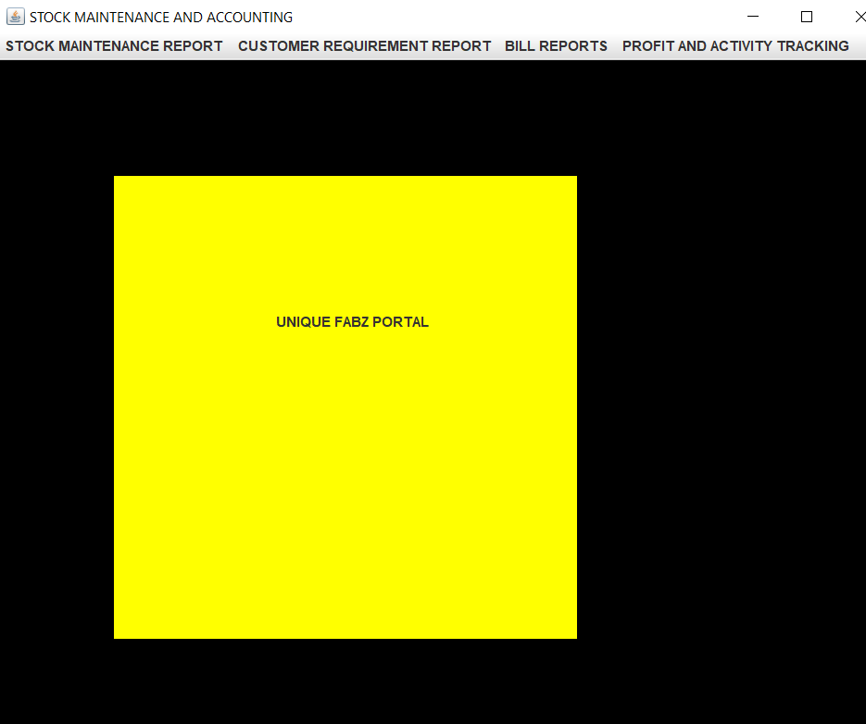

**STOCK MAINTENANCE OPERATIONS MODULE**

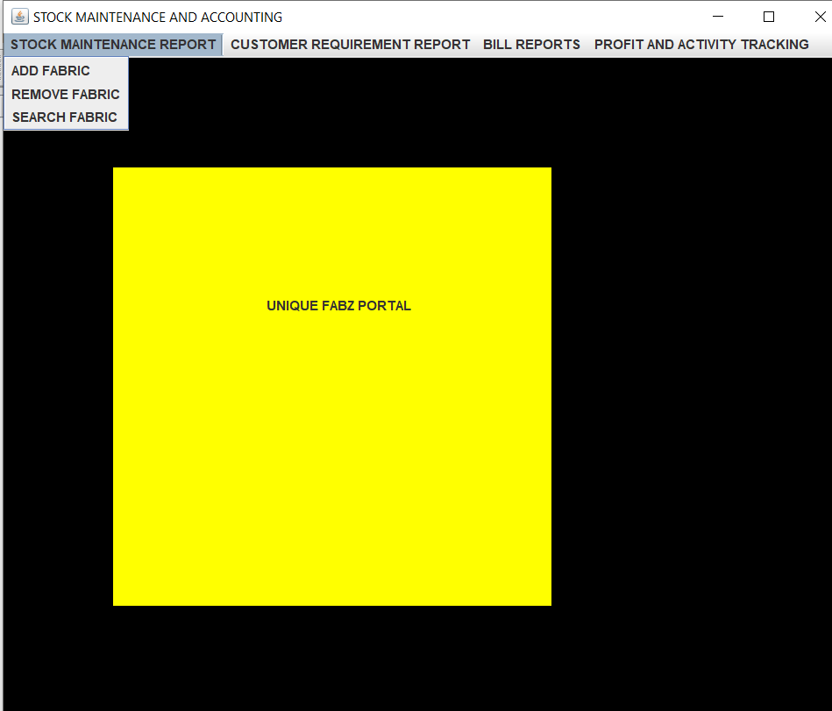

**INSERT FABRIC**

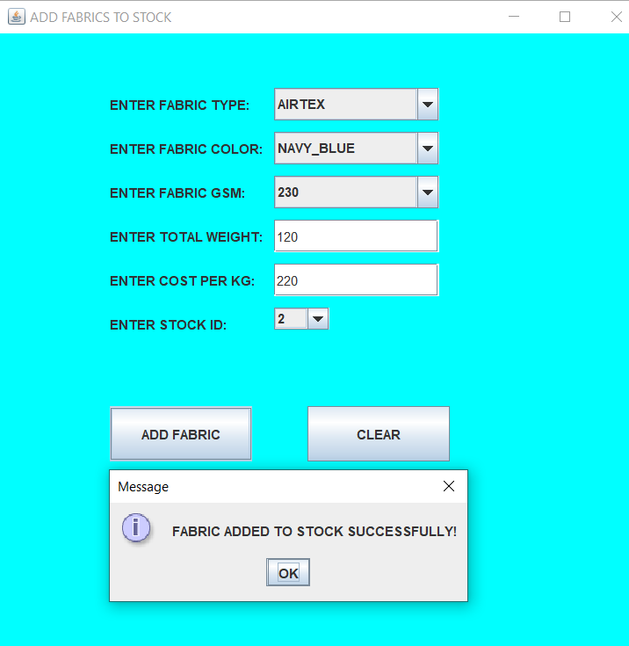

**REMOVE FABRIC**

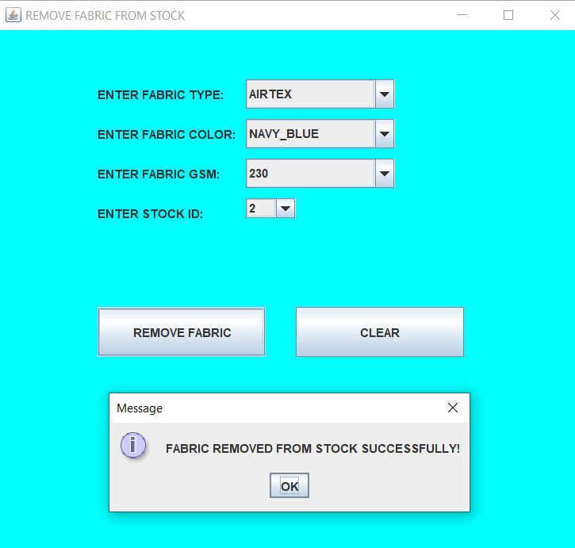

**SEARCH FABRIC**

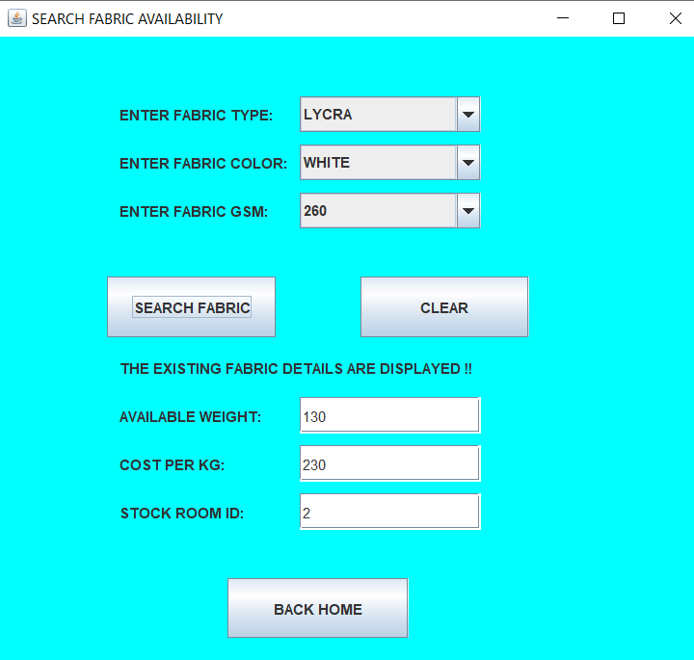

**CUSTOMER DETAILS MAINTENANCE MODULE**

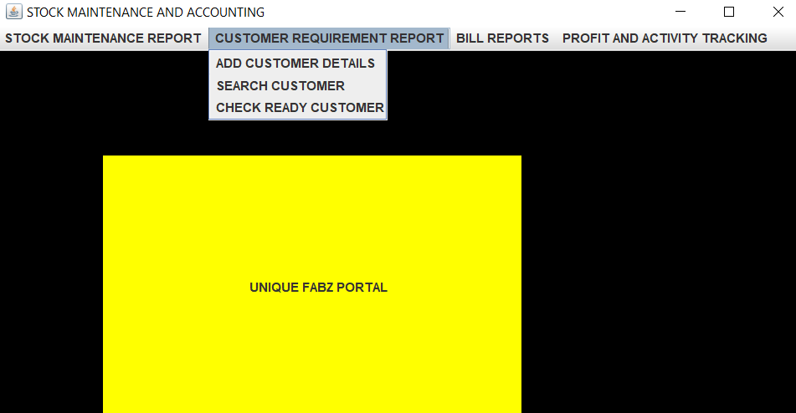

**INSERT CUSTOMER DETAILS**

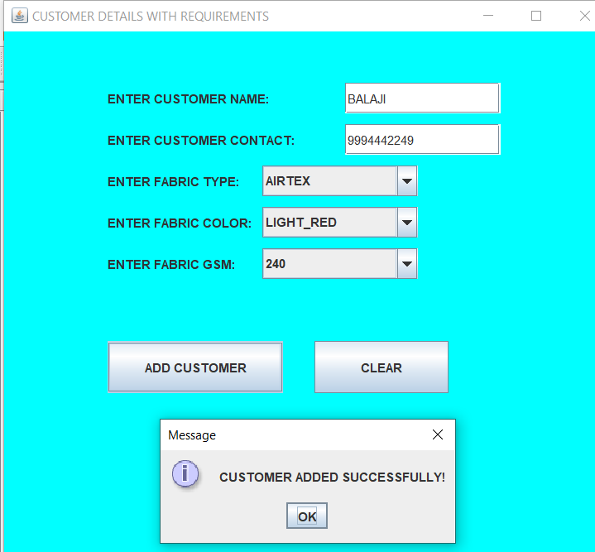

**SEARCH CUSTOMER DETAILS**

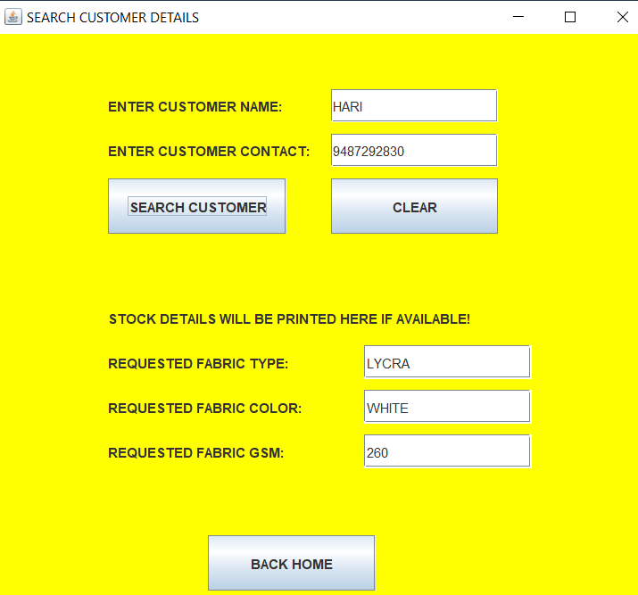

**READY CUSTOMER DETAILS**

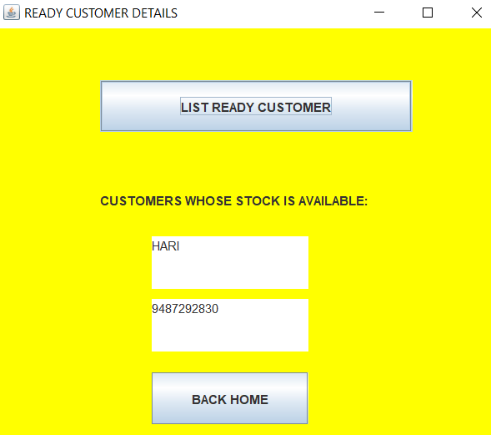

**BILL DETAILS MAINTENANCE MODULE**

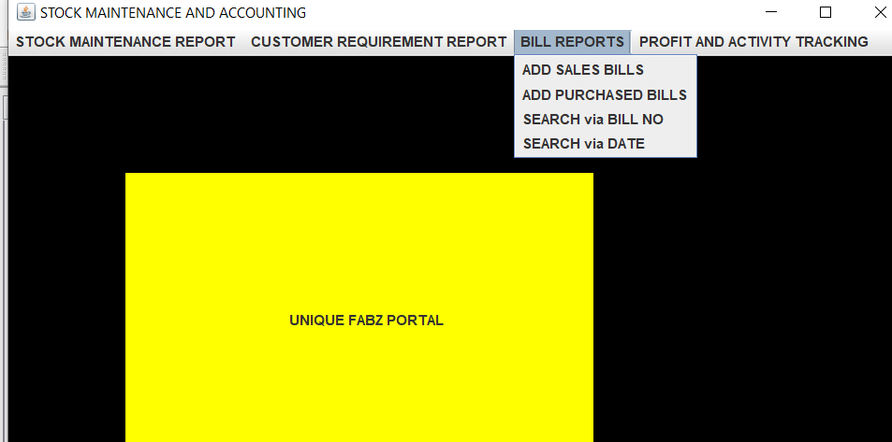

**SALES BILL INSERTION**

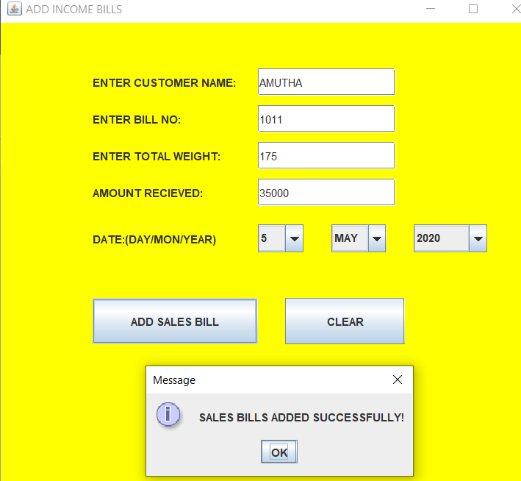

**PURCHASE BILL INSERTION**

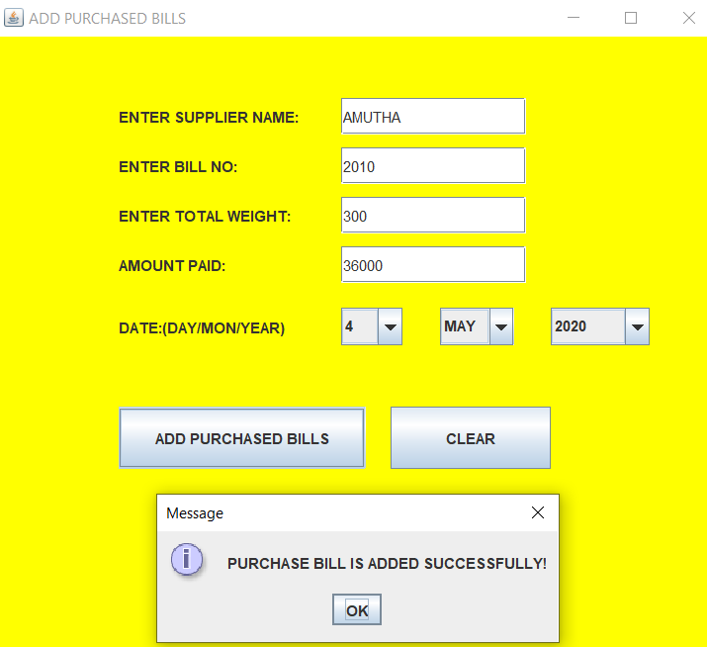

**BILL SEARCH VIA BILL NO**

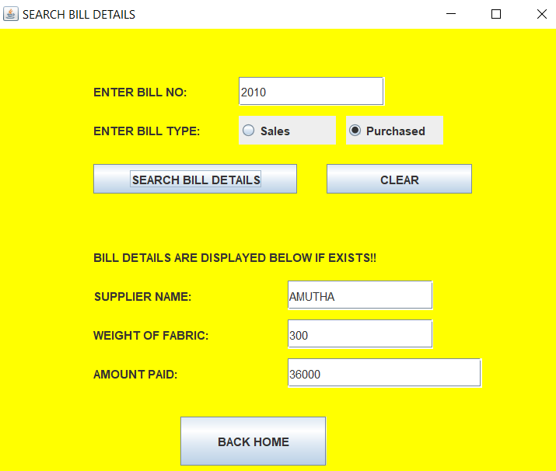

**BILL SEARCH VIA DATE**

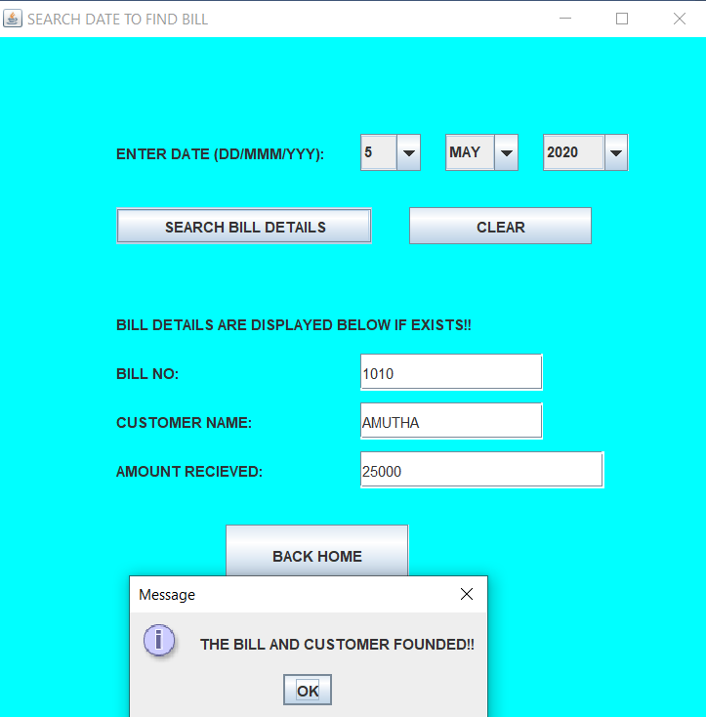

**PROFIT ANALYSIS MODULE**

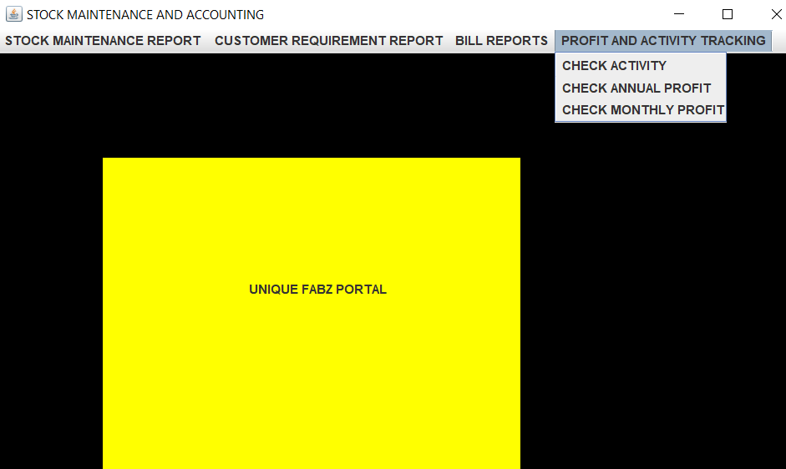

**CHECK TRANSACTION ACTIVITIES REPORT**

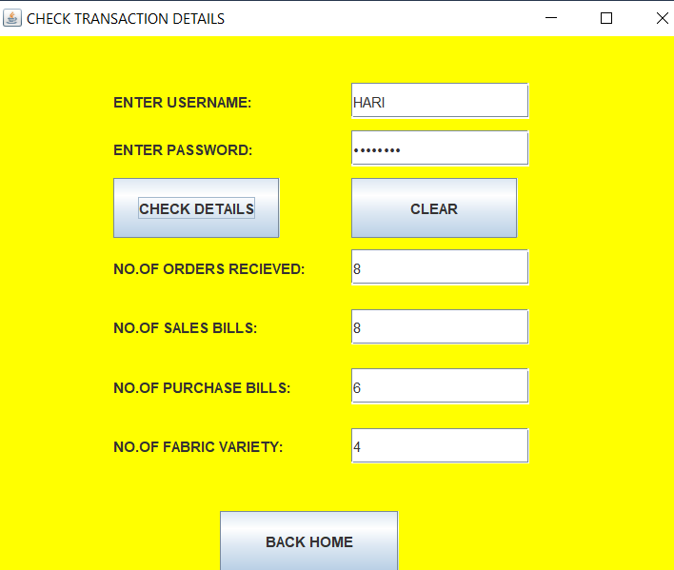

**CHECK OVERALL PROFIT REPORT**

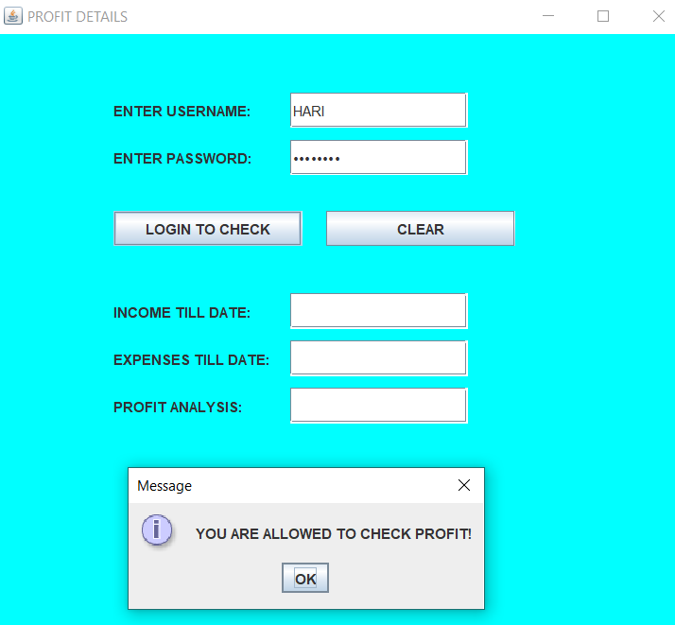

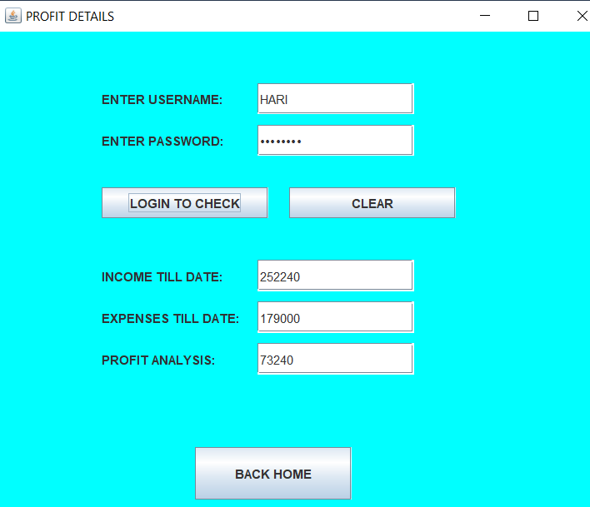

**CHECK PROFIT OF PARTICULAR MONTH**

